First United Church
Seeking to be a welcoming community of Christian faith, proclaiming and celebrating the love of God in Jesus Christ through the Inspiration of the Holy Spirit

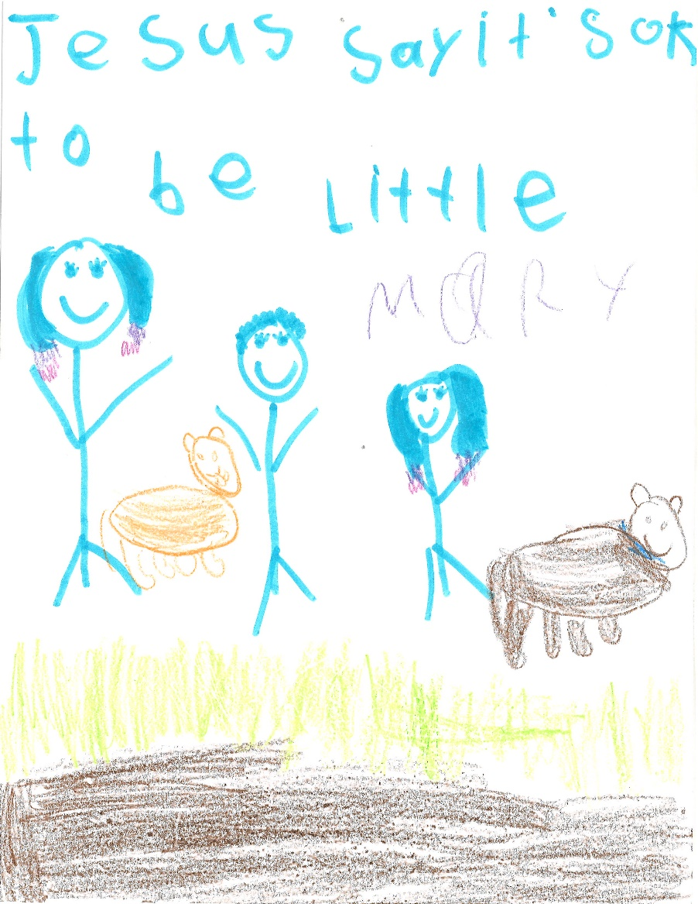

By Mary C.

February 23 2020 @ 10:30am

Order of Service
* You are invited to stand if comfortable doing so

VU = Voices United MV = More Voices

Musical Prelude
Welcome / Life & Work of the Church
Choral Musical Prelude
- MV#25 “O God, Send Out Your Spirit”
O God, send out your Spirit; renew the face of the earth.
O God, send out your Spirit; renew the face of the earth.

- MV#90 “Don’t Be Afraid”
Don’t be afraid. My love is stronger,
my love is stronger than your fear.
Don’t be afraid. My love is stronger
and I have promised, promised to be always near.

Call to Worship
One: God of Creation;
All: In the cardinal through whom our ancestors are said to flit among
us, among the Poplar Trees, content to stand together in a frozen
flood plain,
One: Strong in the one remnant insect this winter-
Spotted just last week, persevering in its assent up a snow boot’s
impression.
All: O, Bathe our humanity in the wilds of your hermitages,
Seep into every portal of ours with delight and contentment,
and soak us in those eternal Cathedrals You call home.

ne: God of Creativity;
All: everywhere we stand, inhale, breathe,
One: Everywhere we wait in attentive stillness,
All: You offer us dwelling places to settle and heal
One: And recreate us for what lies beyond anxiety and trauma.

One: God of Life’s course;
All: There is no dogma or religion that confines you.
One: There is no poem, or song that defines you.
All: You are known only in the journey,
One: Met in the Temples you call us into,
All: Heard through the songs you sing into our hearts,
One: and comprehended,
especially when we sense you are reclaiming us.
All: Holy are You, and Holy is the day you have brought to us.
We delight, as ever, in this tent of meeting.
(Daryl Webber, 2020 inspired by a Sparta Conservation Hike and company!)

Lighting of the Christ Candle
I am the light of world, you people come and follow me.
If we follow and love, we’ll learn the mystery
Of what we were meant to do and be.

Opening Prayer
In great humility,
We recognize
That something within us
Bears witness
To your Holy Spirit, O Divine One.
Spirit has moved in the realities of our lives
In momentous ways and
each time,
you heal us deeper into life.
Each time,
our assumptions change about the Deity,
you open our Holy eyes to see our neighbours anew.
It is in great humility,
We come to give thanks,
And give testimony to a courageous work
That has been set loose
in the way the world
is beheld by us. Amen. (Daryl Webber, 2020)

Passing of the Peace
Sing: Halle, Halle, Halle, lu jah! Halle, Halle, Halle, lu jah!
Halle, Halle, Halle, lu jah! Halle lu jah! (clap) Halle lu jah!

Musical Offering: Senior Choir

Conversation with the Young People

Prayer/The Lord’s Prayer

Hymn: VU#641 “Lord Jesus, You Shall Be My Song” (v 1, 2)

Offering Ourselves, Tithes & Gifts:

Dedication Hymn: (tune “Eidelweiss”)
God of Love, hear our prayer. Bless this offering we bring you. May our lives do Your will; guide and guard us forever. Give us courage to stand for truth; help us give to others. God of Love, hear our prayer, Bless this offering we bring you.

Scripture Reading: Matthew 17:1-9

The Message: Rev. Daryl Webber
Introduction to “Loving God. Living Word.” Series.
“Steps of Faith”

*Hymn: VU#625 “I Feel the Winds of God Today”

*Commissioning
Let nothing disturb you;
Let nothing dismay you;
All things pass:
God never changes.
Patience attains
All it strives for.
Those who have God
Find they lack nothing:
God alone suffices. (Teresa of Avila)
*Benediction
Closing - Sing: VU#209 “Go Make A Difference”
Go make a diff’rence, We can make a diff’rence.
Go make a diff’rence in the world.
Go make a diff’rence, We can make a diff’rence.
Go make a diff’rence in the world.

Musical Postlude

Thank you to Dr. Wayne Carroll
for sharing his musical gifts on the organ.

LIFE & WORK OF THE CHURCH
February 23, 2020

Happy birthday to: Bev Glass, Mike Vecchio, Adam Derganc.

*TODAY: *Join us for Coffee, Cold drinks & Conversation in the Fellowship Room following worship.
(At First we love having a time of Fellowship after Worship on Sundays! It’s a time to greet friends, new and old, over a drink & maybe a goody!! If this is something you would enjoy hosting, you are invited to sign up on the sheet in the Fellowship Room (Drinks supplied – coffee would just need to be put on in the morning!). We’d love to have you!)

*Would you be willing to participate or lead the worship service? If so please speak to Rev. Daryl, Richard Auckland or one of the worship team leaders.

This week:
Tuesday: *EarlyON Playgroup in the Gym - 9:30 – 11:30am

*Shrove Tuesday Pancake Supper in the Assembly Hall from 4:30-6:30pm. Pancakes, sausage, baked beans, dessert & beverage. Adults $6.00; Children 5-10 $4.00; Children 4 & under FREE. (Gluten Free Options Available)

*First Youth with Chris Ross & Justin Chute in Room 3/Gym from 7-8:15pm.

Wednesday – *“Dust & Glory – The Road Ahead” Ash Wednesday Service. An Ecumenical Gathering at St. Andrew’s United Church (60 West Ave, St. Thomas) @ 10:30am. All welcome.

Thursday

*Sr. Choir @ 7:30pm! Don’t be shy – singing’s great for the soul – come and give it a try!

Next Sunday, March 1 – *Baptism

Friday, March 6 – *World Day of Prayer @ Central United Church

Monday, March 9 - *Official Board Meeting @ 7pm.

Monday, March 23 - We will be holding our 2nd Quarter Auction!
Doors open at 6 p.m. Auction starts at 7:00 p.m.
We will have vendors for shopping and food will be available for purchase. Join us for this super fun event! Admission is $5 (includes 1 paddle) Extra paddles are $2 each.

Church Office Hours
Monday to Thursday 8:30am to 3:30pm
(Closed from 12-1pm for lunch)

7 Curtis St., St.Thomas, ON N5P 1H3 Phone: (519) 631-7570
e-mail: office@1stunitedchurch.ca
web: www.1stunitedchurch.ca
MINISTERS: ALL THE PEOPLE OF GOD
Intentional Interim Minister: Rev. Daryl Webber
Music Minister: Jody McDonald-Groulx
Secretary/Treasurer: Lori Hoffman
Custodian: Dave Luftenegger

