First United Church
Seeking to be a welcoming community of Christian faith, proclaiming and celebrating the love of God in Jesus Christ through the Inspiration of the Holy Spirit

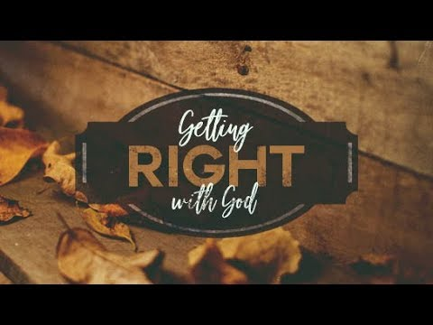

February 17, 2019 @ 10:30am

7 Curtis St., St.Thomas, ON N5P 1H3 Phone: (519) 631-7570
e-mail: office@1stunitedchurch.ca
web: www.1stunitedchurch.ca
MINISTERS: ALL THE PEOPLE OF GOD
Pastoral Minister: Rev. Emmanuel K. Ofori
Music Minister: Jody McDonald-Groulx
Secretary/Treasurer: Lori Hoffman
Custodian: Dave Luftenegger
Sixth Sunday after Epiphany

PREACHER: Rev. Emmanuel K. Ofori
* You are invited to stand if comfortable doing so

VU = Voices United MV = More Voices

We Gather Together
Opening Prayer
Choral Prelude
- “We are the Church”
Chorus: I am the Church! You are the Church!
We are the Church together!
All who follow Jesus, all around the world!
Yes, we’re the Church together.

The Church is not a building, the church is not a steeple,
the church is not a resting place, the church is a people. (Repeat Chorus)

- MV#25 “O God, Send Out Your Spirit “
O God, send out your Spirit; renew the face of the earth.
O God, send out your Spirit; renew the face of the earth.

- MV#21 “Open Our Hearts”
Open our hearts, open our minds.
Open our lives to you O loving God.
(Open our hearts)

Lighting of the Christ Candle
Passing of the Peace (VU 958 “Halle, Halle, Halle”)
Welcome
Life and Work of the Church (see insert)

We Draw Near to Worship
Call to Worship: Psalm 1 (VU#724)
Sunday School children may go downstairs
* Children’s Hymn of Praise: MV#48 “Jump For Joy”
Thanksgiving/Intercessory Prayer
Anthem: Senior Choir
Prayers
Thanksgiving
Intercessory Prayer
Silence
We Respond in Love
Offering
Hymn/Song of Dedication
God of Love hear our prayer, bless this offering we bring you.
May our lives do you will, guide and guard us forever.
Give us courage to stand for truth, help us give to others.
God of Love hear our prayer, bless this offering we bring you.

Offertory Prayer
We Listen for God’s Word
* Hymn of Preparation: VU #376 “Spirit of the Living God”
Scripture Readings
Gospel Reading: Romans 3:19-28
Reader: This is the Word of God
All: Thanks be to God.

The Message: “Getting Right With God”

We Go Out to Serve
*Closing Hymn: VU#577 “I’ve Got Peace Like River”
* Benediction
* Triple Amen
* Commissioning Hymn: VU#884 “You Shall Go Out With Joy” (2x)
You shall go out with joy and be led forth with peace;
the mountains and the hills will break forth before you;
there’ll be shouts of joy, and all the trees of the field
will clap, will clap their hands!
And all the trees of the field will clap their hands,
the trees of the field will clap their hands,
the trees of the field will clap their hands
while you go out with joy!
* Musical Postlude

TODAY’S MESSAGE
We have a sense that we need to get right with God but feel helpless to do it. (Romans 2:21-25).
The question is “How can one make things right with God?”
“… no one can ever be made right with God by doing what the law commands. The law simply shows us how sinful we are” (Romans 3:20).

How does God make us right with Godself?
- We can’t make ourselves righteous.
- God gave us life and showed us the right way to live.

- We rejected the right way (Isaiah 43:6; Romans 1:28; Romans 3:23)
- We cannot be made right with God on our own.
- God had to come up with a plan.

- God has provided a new way to be right with God in Jesus.
We have broken God’s law, and we have to pay the penalty. But the good news is everything you’ve ever done or will ever do wrong in life has already been paid for by Jesus Christ on the cross.
You have been made right with God.
- “[God] saved us, not because of righteous things we had done, but because of his mercy” (Titus 3:5 NLT).
- “God showed His great love for us by sending Jesus to die for us while we were still sinners” (Romans 5:8)

- We have to accept by faith what God has done for us in Jesus.
What you must do to get right with God …
- Turn from all sin
- Believe and accept by faith that what Jesus did on the cross paid for your sins.
- Invite Him into your life through prayer.

What happens next?
You become a part of God’s family (John 1:11-12).

Think about this:
Are you right with God? Do you want to get right with God?
Turn to Jesus Christ today.

