First United Church
Seeking to be a welcoming community of Christian faith, proclaiming and celebrating the love of God in Jesus Christ through the Inspiration of the Holy Spirit

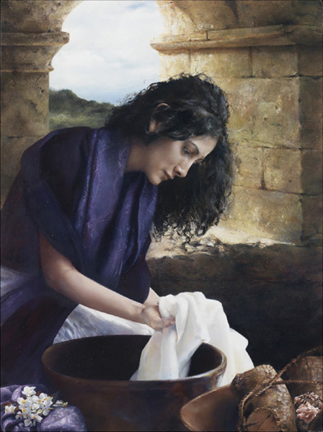

February 16, 2020 @ 10:30am

7 Curtis St., St.Thomas, ON N5P 1H3 Phone: (519) 631-7570
e-mail: office@1stunitedchurch.ca
web: www.1stunitedchurch.ca
MINISTERS: ALL THE PEOPLE OF GOD
Intentional Interim Minister: Rev. Daryl Webber
Music Minister: Jody McDonald-Groulx
Secretary/Treasurer: Lori Hoffman
Custodian: Dave Luftenegger

Order of Service
* You are invited to stand if comfortable doing so

VU = Voices United MV = More Voices

Musical Prelude

Welcome

Choral Musical Prelude
- VU#388 “Spirit Dancing” (v 1 & 2)
Spirit dancing on the waters, sun reflecting song of grace
calling life to all the creatures, giving life to human race.

Spirit dancing on the waters, naming moment they should part,
giving freedom to the peoples, signed for all in dancer’s art.

- MV#18 “Lord, Prepare Me”
Lord, prepare me to be a sanctuary, pure and holy tried and true; with thanksgiving, I’ll be a living sanctuary for you.

Greeting to the Land Please stand as you are able for the Words before all Words.
We acknowledge and greet the Land on which we are gathered. We are reminded that many others honoured this place with the Bowl with One Spoon Wampum Treaty. The Great Lakes Basin was that bowl.
This land – belonging only to Creator God –This land known as Antler River Watershed, was once settled by the Attawandaran Peoples. Later the Algonquin, the Anishininabe, the Lenni-Lenape and the Haudenosaunee Peoples used these lands as their traditional gathering, hunting, and congregating place.
Let us also recognize our three closest neighbours from these nations:
The Chippewas of the Thames First Nation,
The Munsee-Delaware Nation, and
The Oneida Nation of the Thames.
By acknowledging the Land, we are all reminding ourselves of our human connection and our responsibility to care for the land – and to caring for and respecting each other.
Land acknowledgements might seem like a small, even trivial gesture, but like many of our Indigenous ways, they are designed to evolve and allow us to re-imagine the real story of this land past, present, and future – together as Kin in God’s Kin-dom.
Akwe Nia’Tetewá:nereñh. We are All Relations.

Call to Worship
One: We arrange our lives as best we can,
All: to keep your holiness at bay,
with our busy-ness,
our doubts,
our moralities,
our secrets,
One: And then you —
All: you and your dreams,
you and your Word,
you and our neighbors.
Shake up our worlds.
One: We find your holiness not far away,
not distant and unattainable,
All: but right here in front of us,
right under our noses…
One: And we yield, sometimes gladly,
All: sometimes grudgingly,
sometimes late … or soon.
One: We yield because you, beyond us, are our God.
All: We are your creatures met by your holiness,
by your holiness made our true selves.
One: And so we yield. Amen

Lighting of the Christ Candle
I am the light of world, you people come and follow me.
If we follow and love, we’ll learn the mystery
Of what we were meant to do and be.

Opening Prayer
One: CREATOR GOD—We face North, The Direction of Winter.
Winter … when …
All: prevailing winds begin to shift into the northwest, frost decorates windows with intricate designs and on some days trees and hydro wires are flocked with clusters of snowflakes here in the Great Lakes basin.
One: we slow down, enjoy the scene from our window, and by February we yearn to see the signs of spring… days are long and often dark, clouds cover the sun’s warmth and glow, but …
All: we recall that Jesus explained to us a seed must go into the dark and die so that the cycle of new life has its chance. We marvel at the turning seasons and are grateful for Your presence in this turning.
One: Light and life only exist within a cycle, only after darkness and cold can the seed of new life, new hope, new promise poke through the fertile soil of co-operation, collaboration, and community.
All: In facing the direction of the North, we recall the work of building of many generations before us; we remember our ancestors and their accomplishments and lessons passed down; we remember forward and back.
One: We give thanks to The One Who Made All and in whom we live
and move and have our being. Amen.
adapted from one by the Rev. Lee Claus
Passing of the Peace
Sing: Halle, Halle, Halle, lu jah! Halle, Halle, Halle, lu jah!
Halle, Halle, Halle, lu jah! Halle lu jah! (clap) Halle lu jah!

Musical Offering: Carlene MacMenamin & the Band

Life and Work of the Church

Hymn: “I Am the Church”
Refrain: I am the church! You are the church!
We are the church together!
All who follow Jesus, all around the world!
Yes, we're the church together!

- The church is not a building; the church is not a steeple;
the church is not a resting place; the church is a people. (Refrain)
2. We're many kinds of people, with many kinds of faces,
all colours and all ages, too from all times and places. (Refrain)
3. And when the people gather, there's singing and there's praying;
there's laughing and there's crying sometimes, all of it saying:
(Refrain)
- I count if I am ninety, or nine or just a baby
There’s one thing I am sure about And I don’t mean maybe.
(Refrain)

Conversation with the Young People: “Here is the Church” susanna

Prayers of the People
One: LORD, sometimes life gets messy and dreary – just like these
last weeks of winter.
We feel discouraged. We feel forlorn and forgotten.
ALL: And so … we gather together in this Your House
to refresh our memories and renew our resolution
to follow your lead.
Without this opportunity, we might sink into despair.
One: We come here together to re-member who we are
and whose we are, and to remember what our true purpose is.
ALL: And as we are reminded, so we rejoice,
we cannot keep from singing.
Thank you for this gathering place, these people,
and most of all for your Word
and the promise of Jesus’ resurrection.
One: We come before you in that promise of your son and
our brother to express our deep gratitude
by renewing our vow to follow the Way. Amen.
Together we recall The New Creed
We are not alone,
we live in God’s world.
We believe in God:
who has created and is creating,
who has come in Jesus, the Word made flesh,
to reconcile and make new,
who works in us and others
by the Spirit.
We trust in God.
We are called to be the Church:
to celebrate God’s presence,
to live with respect in Creation,
to love and serve others,
to seek justice and resist evil,
to proclaim Jesus, crucified and risen,
our judge and our hope.
In life, in death, in life beyond death,
God is with us.
We are not alone.
Thanks be to God.

Hymn: VU#595 “We Are Pilgrims on a Journey (v 1-4)

Offering Ourselves, Tithes & Gifts
Dedication Hymn: (tune “Eidelweiss”)
God of Love, hear our prayer. Bless this offering we bring you. May our lives do Your will; guide and guard us forever. Give us courage to stand for truth; help us give to others. God of Love, hear our prayer, Bless this offering we bring you.

Scripture Readings: Acts 16: 13-15
On the sabbath day we went outside the gate by the river, where we supposed there was a place of prayer; and we sat down and spoke to the women who had gathered there. A certain woman named Lydia, a worshiper of God, was listening to us; she was from the city of Thyatira and a dealer in purple cloth. The Lord opened her heart to listen eagerly to what was said by Paul. When she and her household were baptized, she urged us, saying, “If you have judged me to be faithful to the Lord, come and stay at my home.” And she prevailed upon us.

A reading from the Gospel of Matthew 10:40-42 (NRSV)
“Whoever welcomes you welcomes me, and whoever welcomes me welcomes the one who sent me.
Whoever welcomes a prophet in the name of a prophet will receive a prophet’s reward; and whoever welcomes a righteous person in the name of a righteous person will receive the reward of the righteous and whoever gives even a cup of cold water to one of these little ones in the name of a disciple—truly I tell you, none of these will lose their reward.”

The Message: “Humble Beginnings” susanna suchak

Hymn: VU#602 “Blest Be the Tie That Binds”

*Commissioning / Benediction
May the blessings of God, the creative Source of the universe,
revitalise us to be the church in the world;
May the blessings of Jesus, the light of the world, disturb us into
compassion for those who hunger to be seen;
May the blessings of Spirit, energy of the cosmos,
animate our words and thoughts into action;
So may we be both blessed and a blessing to all
who cross our path every day of our lives.
And may the people say, AMEN!

adapted from an Iona liturgy

and so …
Let us go out with joy
Awakened to the treasure within and around us,
To bring transformation, challenge and hope to the world.
And may the abundant blessings of God,
Maker, Man and Mystery – Sacred Three in One
Be ours today and always,
guiding and sustaining us in all our tomorrows. Amen.

Closing - Sing: VU#209 “Go Make A Difference”
Go make a diff’rence, We can make a diff’rence.
Go make a diff’rence in the world.
Go make a diff’rence, We can make a diff’rence.
Go make a diff’rence in the world.

Musical Postlude
LIFE & WORK OF THE CHURCH
February 16, 2020

Thank you to Susanna Suchak
for sharing her message with us this morning.

Happy birthday to: Sherry Kingswood, Gerdy MacKay, Brenda Smith, Grant Whiteman, Marg Epp, Mary Ann Rayner.

*TODAY: *Join us for Coffee, Cold drinks & Conversation in the Fellowship Room following worship.
(At First we love having a time of Fellowship after Worship on Sundays! It’s a time to greet friends, new and old, over a drink & maybe a goody!! If this is something you would enjoy hosting, you are invited to sign up on the sheet in the Fellowship Room (Drinks supplied – coffee would just need to be put on in the morning!). We’d love to have you!)

*Would you be willing to participate or lead the worship service? If so please speak to Rev. Daryl, Richard Auckland or one of the worship team leaders.

This week:
Monday *Family Day – Church Office closed

Tuesday: *EarlyON Playgroup in the Gym - 9:30 – 11:30am
*First Youth with Chris Ross & Justin Chute in Room 3/Gym from 7-8:15pm.

Thursday

*Sr. Choir @ 7:30pm! Don’t be shy – singing’s great for the soul – come and give it a try!

Next Sunday, February 23 – *Rev Daryl is back!

Tuesday, February 25 – Shrove Tuesday Pancake Supper in the Assembly Hall from 4:30-6:30pm. Pancakes, sausage, baked beans, dessert & beverage. Adults $6.00; Children 5-10 $4.00; Children 4 & under FREE. (Gluten Free Options Available)

Wednesday, February 26 – “Dust & Glory – The Road Ahead” Ash Wednesday Service. An Ecumenical Gathering at St. Andrew’s United Church (60 West Ave, St. Thomas) @ 10:30am. All welcome.

Friday, March 6 – World Day of Prayer @ Central United Church

Monday, March 23 - We will be holding our 2nd Quarter Auction!
Doors open at 6 p.m. Auction starts at 7:00 p.m.
We will have vendors for shopping and food will be available for purchase. Join us for this super fun event! Admission is $5 (includes 1 paddle) Extra paddles are $2 each.

First Church Library News
Last Sunday Rev Daryl introduced us to the book
“I Don’t Want to be a Frog”.
A grandmother in the congregation tapped me on the shoulder
and suggested it should be in the Church Library.
Our local bookstore had it in stock,
so it is now available in our Library!
(Just remember to sign it out!)
While in our Library, check out the other books we have.
Edith Nimmo

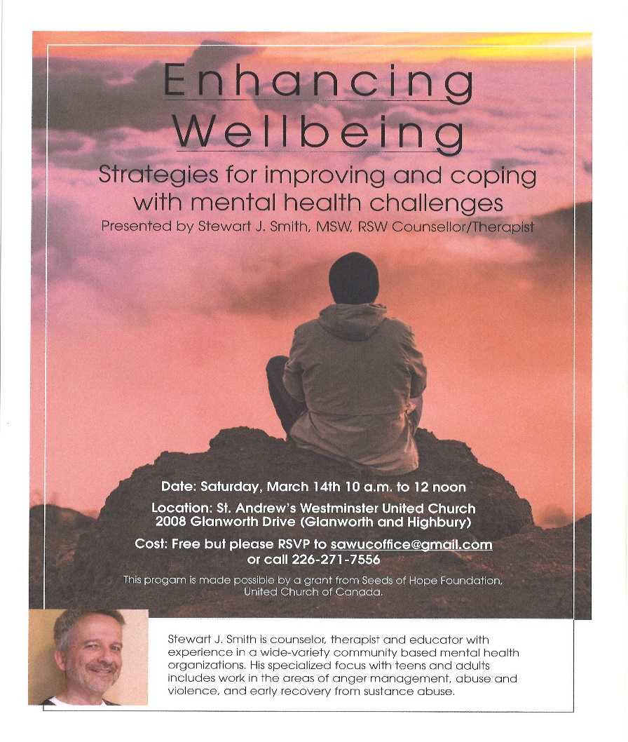

Church Office Hours
Monday to Thursday 8:30am to 3:30pm
(Closed from 12-1pm for lunch)

7 Curtis St., St.Thomas, ON N5P 1H3 Phone: (519) 631-7570
e-mail: office@1stunitedchurch.ca
web: www.1stunitedchurch.ca
MINISTERS: ALL THE PEOPLE OF GOD
Intentional Interim Minister: Rev. Daryl Webber
Music Minister: Jody McDonald-Groulx
Secretary/Treasurer: Lori Hoffman
Custodian: Dave Luftenegger

