First United Church
Seeking to be a welcoming community of Christian faith, proclaiming and celebrating the love of God in Jesus Christ through the Inspiration of the Holy Spirit

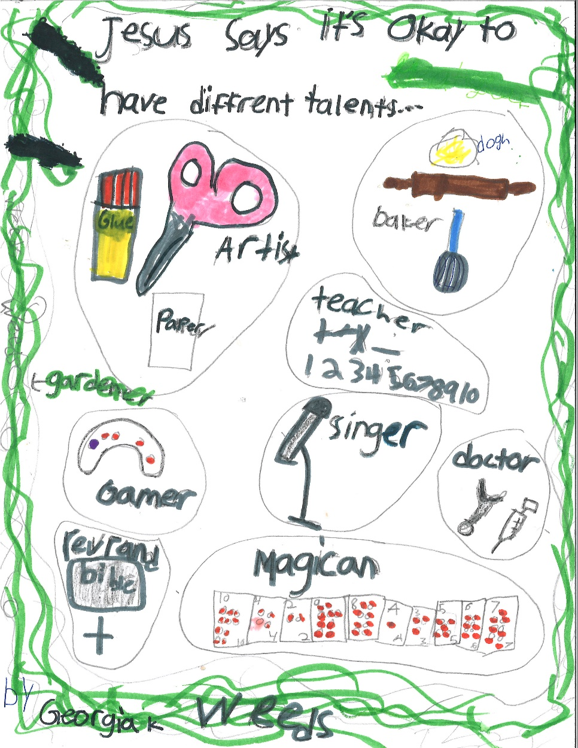

By Georgia K.

February 9, 2020 @ 10:30am

Order of Service
* You are invited to stand if comfortable doing so

VU = Voices United MV = More Voices

Musical Prelude
Welcome / Life & Work of the Church
Choral Musical Prelude
- VU#649 “Walk With Me” (2x)
Walk with me, and I will walk with you
and build the land that God has planned
where love shines through.

- MV#8 “And on this Path”
And on this path, the gates of holiness are open wide,
And on this path, the gates of holiness are open wide,
And on this path, the gates of holiness are open wide,
Open wide! Open wide! Open wide! The gates are open wide!

So enter in, the gates of holiness are open wide,
So enter in, the gates of holiness are open wide,
So enter in, the gates of holiness are open wide,
Open wide! Open wide! Open wide! The gates are open wide!

Call to Worship
One: We stand at the door of God’s house,
All: looking back and looking forward.
One: We stand at the door of our lives,
All: wondering what we will find when we open it wide.
One: We stand at the door of this moment,
All: knowing that God is here,
knowing that God is with us – no matter what.
One: Live or die – or be reborn
All: God is with us. Alleluia!
One: In the name of Jesus Christ, the one true head of the church
this gathering is called to order,
All: for worship and work, appropriate to it’s time.
(Richard Bott, St Andrew’s UC, Maple Ridge BC)

Lighting of the Christ Candle
I am the light of world, you people come and follow me.
If we follow and love, we’ll learn the mystery
Of what we were meant to do and be.

Opening Prayer
Great and Glorious God,
we meet to discuss the life and work of this church family,
praying that we recognize you in our discussion.
Great Spirit move our hearts, opening them,
that we can hear what each of us has to offer,
and celebrate the many gifts we all have to contribute.
Open the eyes of our souls to see light shine
in both possibilities and realities,
and to follow you into this time and place.
We are reminded that we are bearers of Christ’s life,
light, and love to all we meet.
Bless the way we practice faith on our journey
and the witness we share of your life in us.
Bless us as we reflect on our journey over the last year.
These things we pray in the name of Jesus of Nazareth,
the one we call Christ,
in his name and hope we gather together as a community.

Passing of the Peace
Sing: Halle, Halle, Halle, lu jah! Halle, Halle, Halle, lu jah!
Halle, Halle, Halle, lu jah! Halle lu jah! (clap) Halle lu jah!

Musical Offering: Senior Choir

Conversation with the Young People

Prayer/The Lord’s Prayer

Hymn: MV#154 “Deep In Our Hearts”

Offering Ourselves, Tithes & Gifts:

Dedication Hymn: (tune “Eidelweiss”)
God of Love, hear our prayer. Bless this offering we bring you. May our lives do Your will; guide and guard us forever. Give us courage to stand for truth; help us give to others. God of Love, hear our prayer, Bless this offering we bring you.

In Memoriam
We remember those who passed into blessed memory in 2019
Bruce Glover – January 19, 2019
Mara Hawkins – February 11, 2019
Mack Jackson – April 6, 2019
Michael Gormley – June 2, 2019
Peter Morrow – July 9, 2019
Marion McKenzie – July 12, 2019
Frances Ahara - August 5, 2019
Robert Brooks – October 3, 2019
Roxene Chaulk - November 12, 2019

Scripture Reading: Matthew 5:12-20

The Message: Rev. Daryl Webber

*Hymn: “Shine, Jesus Shine”
Lord, the light of Your love is shining,
In the midst of the darkness shining;
Jesus, Light of the world, shine upon us,
Set us free by the truth You now bring us;
Shine on me. Shine on me.

Shine, Jesus Shine, fill this land with the Father’s glory.
Blaze, Spirit blaze, set our hearts on fire.
Flow, river flow, flood the nations with grace and mercy.
Send forth Your word, Lord, and let there be light.

*Grace
We begin this meal with grace.
For the joy and nourishment of food,
the slowed time away from the world
to come into presence with each other
and sense the subtle lives behind our faces,
the different colors of our voices,
the edges of hungers we keep private,
the circle of love that unites us.
We pray the wise spirit who keeps us
To change the structures that make others hunger
And that after such grace we might now go forth
and impart dignity wherever we partake.
– John O’Donohue from “To Bless the Space Between Us: A Book of Blessings”

Please join us in the Assembly Hall for lunch
and our Annual General Meeting.

11:20am – Pizza Lunch & Table conversations lead by the
Transition Team

12:10pm - Formal beginning to Annual Meeting

12:45pm - Closing Prayer / Commissioning
(at latest)

LIFE & WORK OF THE CHURCH
February 9, 2020

Happy birthday to: Nancy Copeland, Marg Sanderson, Noah Derganc, Vayda Harris, Joe Fellows, Gerry Derganc.

*TODAY: *2019 Tax Receipts are available following worship in Lori’s Office (they will be put in the mail tomorrow)

*Annual Reports will be available downstairs for those who don’t have them.

*At First we love having a time of Fellowship after Worship on Sundays! It’s a time to greet friends, new and old, over a drink & maybe a goody!! If this is something you would enjoy hosting, you are invited to sign up on the sheet in the Fellowship Room (Drinks supplied – coffee would just need to be put on in the morning!). We’d love to have you!

*Would you be willing to participate or lead the worship service? If so please speak to Rev. Daryl, Richard Auckland or one of the worship team leaders.

This week:
Monday *Coffee & Conversation with Rev. Daryl from 10-11am.

Tuesday: *EarlyON Playgroup in the Gym - 9:30 – 11:30am
*First Youth with Chris Ross & Justin Chute in Room 3/Gym from 7-8:15pm.

Thursday

*Sr. Choir @ 7:30pm! Don’t be shy – singing’s great for the soul – come and give it a try!

Next Sunday, February 16 – *Rev Daryl is away. Our guest speaker will be Susanna Suchak.

Tuesday, February 25 – Shrove Tuesday Pancake Supper in the Assembly Hall from 4:30-6:30pm. Pancakes, sausage, baked beans, dessert & beverage. Adults $6.00; Children 5-10 $4.00; Children 4 & under FREE.

Friday, March 6 – World Day of Prayer @ Central United Church

Church Office Hours
Monday to Thursday 8:30am to 3:30pm
(Closed from 12-1pm for lunch)

7 Curtis St., St.Thomas, ON N5P 1H3 Phone: (519) 631-7570
e-mail: office@1stunitedchurch.ca
web: www.1stunitedchurch.ca
MINISTERS: ALL THE PEOPLE OF GOD
Intentional Interim Minister: Rev. Daryl Webber
Music Minister: Jody McDonald-Groulx
Secretary/Treasurer: Lori Hoffman
Custodian: Dave Luftenegger

