First United Church
Seeking to be a welcoming community of Christian faith, proclaiming and celebrating the love of God in Jesus Christ through the Inspiration of the Holy Spirit

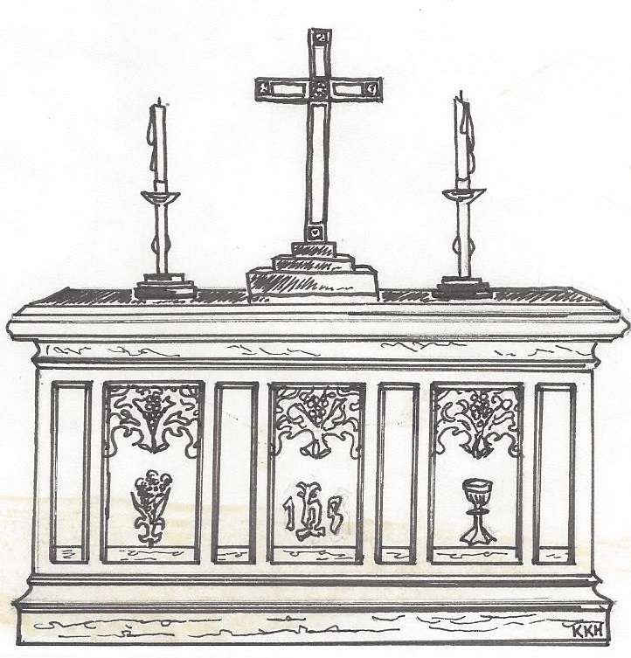

February 03, 2019 @ 10:30am

7 Curtis St., St.Thomas, ON N5P 1H3 Phone: (519) 631-7570
e-mail: office@1stunitedchurch.ca
web: www.1stunitedchurch.ca
MINISTERS: ALL THE PEOPLE OF GOD
Pastoral Minister: Rev. Emmanuel K. Ofori
Music Minister: Jody McDonald-Groulx
Secretary/Treasurer: Lori Hoffman
Custodian: Dave Luftenegger

Fourth Sunday After Epiphany

PREACHER: Rev. Emmanuel K. Ofori
* You are invited to stand if comfortable doing so

VU = Voices United MV = More Voices

We Gather Together
Opening Prayer

Choral Musical Prelude:
- MV#156 “Dance with the Spirit” (2x)
Dance with the Spirit early in the mornin’
Walk with Spirit throughout the long day,
Work and hope for the new life abornin’,
Listen to the Spirit to show you the way.

- “That’s Why We Praise Him” (Chorus only) (2x)
That’s why we praise him, that’s why we sing
That’s why we offer him our everything
That’s why we bow down, and worship this King
‘Cause He gave His everything
‘Cause He gave His everything.

- MV#18 “Lord, Prepare Me…” (2x)
Lord prepare me, to be a sanctuary,
pure and holy tried and true
With thanksgiving, I’ll be a living sanctuary for you.

Lighting of the Christ Candle
Passing of the Peace (VU #958 “Halle, Halle, Halle”)
Welcome/Life and Work of the Church

We Draw Near to Worship
Call to Worship: Responsive Reading (Luke 1:47-55) VU pg #898

Sunday School children may go downstairs
Hymn: VU #562 “Jesus Calls Us” [vs. 1, 5]
Reception of new member
Ministry of Music: Senior Choir
We Respond in Love
Offering/Song Ministration:
Hymn of Dedication
God of Love hear our prayer, bless this offering we bring you.
May our lives do your will, guide and guard us forever.
Give us courage to stand for truth, help us give to others.
God of Love hear our prayer, bless this offering we bring you.

Offertory Prayer
We Break Bread Together
* Communion Hymn: VU#501 “Break Now the Bread of Life”
God be with you.

And also with you

Lift up your hearts

We lift up our hearts unto the Lord

Let us give thanks to God

It is good and pleasant to give God thanks and praise

It is good and pleasant thing, our joy and our moral duty, … to give you thanks and praise,… Therefore, with angels and archangels, and with all the heavenly host, we join in the hymn of everlasting praise saying …

Holy, holy, holy, LORD God of hosts,
heaven and earth are full of your glory.
Hosanna in the highest.
Glory be to you, O Lord, most high. Amen.

Prayer of Consecration
Invitation

Distribution of Elements

We Listen for God’s Word
Scripture Readings: Exodus 17:8-13; Acts 6:1-4
Reader: This is the Word of God
All: Thanks be to God.

* Hymn of Preparation: VU #385 “Spirit Dive, Attend Our Prayers”
The Message: “Telephone to Heaven”

We Go Out to Serve
*Closing Hymn: VU#431 “Sing Amen”
* Benediction
* Triple Amen
* Commissioning Hymn: MV#209 “Go Make a Diff’rence”
* Musical Postlude

TODAY’S MESSAGE
As a community of faith, First United has a vision of becoming a vibrant church …
- a church that worships the Lord with joy;
- a church that engages the youth and young families in ministry;
- a church that reaches out to others with the love of God in Christ.

One of the marks of a vibrant church is prayer. We find this in the life of the early believers in the New Testament. Theirs was a vibrant church because it was a praying church. The Early Church models for us what it means to be a praying church.

- Prayed together – first congregational prayer meeting (Acts 1:14)
- Prayed before choosing replacement of Judas (1:24)
- Prayed in the upper room on the Day of Pentecost (Acts 2:1)
- Prayed for boldness after persecution (Acts 4:24-31)
- Prayed before choosing leaders – great growth resulted (Acts 6:6-7)
- Prayed the dead back to life – resulting in growth (Acts 9:40-42)
- Prayed for the release of Peter from prison (Acts 12:12)
- Prayed before sending forth the first Missions Team (Acts 13:1-3)
- Prayed in prison – jailer and household converted (Acts 16:25)

Think about this:
- God acts in response to the prayers of God’s people.
- Make a commitment to be a praying believer; Keep praying for First United, youth and young families, and our city.

