First United Church
Seeking to be a welcoming community of Christian faith, proclaiming and celebrating the love of God in Jesus Christ through the Inspiration of the Holy Spirit

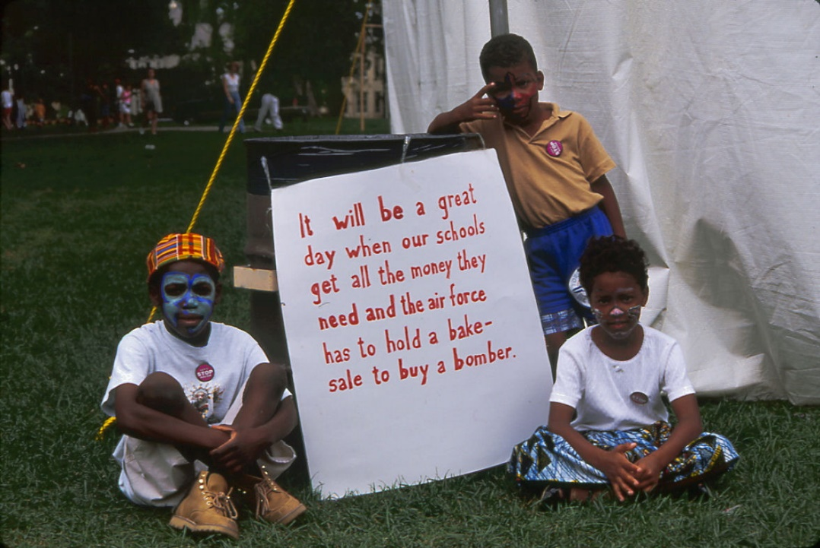

“Blessed are the pure in heart,
for they will see God.”
Matthew 5:8

February 2, 2020 @ 10:30am

7 Curtis St., St.Thomas, ON N5P 1H3 Phone: (519) 631-7570
e-mail: office@1stunitedchurch.ca
web: www.1stunitedchurch.ca
MINISTERS: ALL THE PEOPLE OF GOD
Intentional Interim Minister: Rev. Daryl Webber
Music Minister: Jody McDonald-Groulx
Secretary/Treasurer: Lori Hoffman
Custodian: Dave Luftenegger
Order of Service
* You are invited to stand if comfortable doing so

VU = Voices United MV = More Voices

Musical Prelude
Welcome / Life & Work of the Church
Choral Musical Prelude
- MV#51 “Yahweh Be Praised” (2x)
Yahweh be praised in the heavens.
Yahweh be praised in the streets.
Yahweh be praised with our singing
when in worship we meet.
Yahweh be praised. Yahweh be praised.
Yahweh be praised. Yahweh be praised.
Yahweh be praised. Yahweh be praised.
Yahweh be praised. Yahweh be praised.

Call to Worship
One: The past cannot shackle us.
All: Be glad and rejoice forever!
One: Our fears will not limit us.
All: Be glad and rejoice forever!
One: And we shall be a people in whom our God delights,
who creates a new heaven and a new earth!
All: Let us be glad as we come to worship!
Let us rejoice forever as we sing! Rod Sykes

Lighting of the Christ Candle
I am the light of world, you people come and follow me.
If we follow and love, we’ll learn the mystery
Of what we were meant to do and be.

Passing of the Peace
Sing: Halle, Halle, Halle, lu jah! Halle, Halle, Halle, lu jah!
Halle, Halle, Halle, lu jah! Halle lu jah! (clap) Halle lu jah!

Opening Prayer
Great and Glorious God,
Great and Glorious not because you are some “old bearded guy”,
but Great and Glorious in that you are unafraid of intimacy,
unafraid of creating and then recreating us,
unashamed to mend us when shame shreds us,
uninhibited in deepening our awareness of being your disciples,
determined to stretch our capacity to birth that person
you’ve planted in us,
desirous that we be marked with joy and carry that anointing into life.
Great and Glorious God, you are casting out all
that is “sterile” in us,
and setting your prophets of freedom to work in us.
Let every confession and affirmation that
strengthens the sacred be set loose today.
In Jesus’ name, we pray. (Daryl Webber)

*Communion Hymn: VU#460 “All Who Hunger” (v. 1 & 2)

Invitation to Communion
One: Rejoice before God you and your children.
All: Rejoice with the stranger, the widowed, the orphan.
One: Rejoice, you who were once enslaved.
All: Break the bread of freedom.
Drink deep from laughter’s cup.
One: Rejoice, for God has blessed us in all we produce,
in all we undertake.
All: Together, let us celebrate.

Call to Give Thanks
One: The Lord be with you.
All: And also with you.
One: Lift up your hearts.
All: We lift them up to God.
One: Let us give thanks to the Lord our God.
All: It is right to give our thanks and praise.

Prayer of Thanksgiving
In our joy, you are the overflowing cup;
in our need, you are the bread by which we journey on.
With all who abide in your presence and care,
we lift our voices to sing:
Sing
VU pg 932: Holy, holy, holy are you,
God of power and might,
Hosanna and earth are filled with your glory.
Hosanna in highest.
Blessed in the one who comes in your name.
Hosanna in the highest. Hosanna in the highest.

Remembering Jesus at the Table
By remembering Jesus is the way now,
we claim our common heritage,
and join with Him in the work of our generation.
Together we proclaim the mystery of faith:

Sing
VU pg 933: Christ has died.
Christ has risen.
Christ will come again.

Fraction: Distribution

Musical Offering: Senior Choir

Prayer After Communion
All: Life-giving God,
may we, who share Christ’s body, live his risen life;
may we, who drink His cup, bring new life to others;
may we, whom the Spirit lights, give light to the world.
Keep us firm in the hope you have set before us,
So that we and all your children shall be free,
And all creation will live to praise your name. Amen

*Hymn: MV#202 “Bread for the Journey (2x)
Bread for the journey, food for the way.
Cup of God’s blessing, tomorrow, today.

Offering Ourselves, Tithes & Gifts: Hailey Clark
*Dedication Hymn: (tune “Eidelweiss”)
God of Love, hear our prayer. Bless this offering we bring you. May our lives do Your will; guide and guard us forever. Give us courage to stand for truth; help us give to others. God of Love, hear our prayer, Bless this offering we bring you.
Scripture Readings: Matthew 5:1-12

The Message: Rev. Daryl Webber

*Hymn: VU#896 “Blest Are They – Matthew 5”

*Commissioning/Benediction
Closing - Sing: VU#209 “Go Make A Difference”
Go make a diff’rence, We can make a diff’rence.
Go make a diff’rence in the world.
Go make a diff’rence, We can make a diff’rence.
Go make a diff’rence in the world.

Musical Postlude

LIFE & WORK OF THE CHURCH
February 2, 2020

A Note from Gerdy & Noel MacKay
Friends at First United, Noel and I wish to thank you for your support, your messages, cards and gifts of food. Your prayers sustained me while hospitalized and I ask for your continued prayerful support as a long road of recovery lies ahead.
We are blessed to have a circle of prayerful people surrounding us.
All in all I am truly grateful for what God’s mercy and grace are afforded me. Truly blessed. In His name, Gerdy and Noel

Happy birthday to: Debbie Alward

*TODAY: *2019 Tax Receipts are available following worship in Lori’s Office (available in the office up until Sunday, February 9 – then they will be put in the mail).

*Annual Reports are available in the library to take home – Please remember to bring them back for the Annual Meeting next Sunday.
*You are invited to join us refreshments in the Fellowship following worship.

*At First we love having a time of Fellowship after Worship on Sundays! It’s a time to greet friends, new and old, over a drink & maybe a goody!! If this is something you would enjoy hosting, you are invited to sign up on the sheet in the Fellowship Room (Drinks supplied – coffee would just need to be put on in the morning!). We’d love to have you!

*Would you be willing to participate or lead the worship service? If so please speak to Rev. Daryl, Richard Auckland or one of the worship team leaders.

This week:
Everyone is asked to email in photos from the last year or so to capture our life together (you can bring photos in to the office if you don’t email). These photos will be shared in a slideshow on Sunday, February 9 at the Annual Meeting. Please send them to office@1stunitedchurch.ca Thank you!

Monday *Coffee & Conversation with Rev. Daryl from 10-11am.

Tuesday: *EarlyON Playgroup in the Gym - 9:30 – 11:30am
*First Youth with Chris Ross & Justin Chute in Room 3/Gym from 7-8:15pm.

Thursday

*Sr. Choir @ 7:30pm! Don’t be shy – singing’s great for the soul – come and give it a try!

Next Sunday, February 9 – Annual General Meeting of the Congregation following worship in the Assembly Hall. Lunch will be provided.

A Note from Lori & the Finance Committee
There are still a few sets of 2020 Offering envelopes in the Library waiting to be picked up!
REMINDER!! Please DO NOT use any old envelopes or envelope numbers! Doing so could cause your offering to be inadvertently credited to another person.
If you go to pick up a set of envelopes and there isn’t one there with your name on it, please contact Lori in the office and she can arrange to get you a set.

Church Office Hours
Monday to Thursday 8:30am to 3:30pm
(Closed from 12-1pm for lunch)

