FALL & CHRISTMAS HAPPENINGS
AT FIRST UNITED CHURCH

Sun., Sept. 11 – RALLY DAY @ FIRST CHURCH

Worship @ 10:30am - A great lunch of hamburgers, hot dogs and french fries! (see flyer)

Thurs., Sept. 15 - SENIOR CHOIR @ 7:30pm!

Don’t be shy – singing’s great for the soul – come and give it a try!

Sun., Sept. 18 – WORSHIP @ 10:30am
CHURCH SCHOOL and NURSERY BEGIN!! (see flyer)

Sun., Oct. 9 - WORSHIP @ 10:30am
THANKSGIVING SUNDAY (see flyer)

Sat., Oct. 15 - DOORS OPEN at First Church (see flyer)

Mon., Oct. 17 – FIRST CHURCH BOSTON PIZZA NIGHT 5:30-7:00pm. (see flyer)

Sat., Oct. 22 – RUMMAGE SALE 8:30 – 11:30 am
We hope you take some time in the next few weeks to clean out your
closets, attics and basements and donate your gently used items to our sale! Looking for fall and winter clothing, special ladies wear for our popular boutique, shoes, boots, hats, mittens, china, glassware, vintage items, fall and Christmas decorations, jewellery, luggage, small household items (please no TVs, microwaves or computers), books, games and toys. Donated items may be left inside west accessibility door Mon. - Thurs. 9am-2:30pm. Please call Lois Whiteman 519-631-3337 if you are able to help sort and price the weeks before the sale or if you would like to work sale day. Thankyou!

Sun., Nov. 8 - WORSHIP @ 10:30am: REMEMBRANCE SUNDAY
SECRET SANTA BAGS available - our way of giving to Christmas Care

Sat., Nov. 19 – THE HOLLY FAIR - our Christmas Bazaar! 9am to noon

Sun., Nov. 27 – WORSHIP @ 10:30am: ADVENT 1 CELEBRATION
We trim the sanctuary Christmas tree together. A catered lunch for all
following the service.

Sun., Dec. 4 – WORSHIP @ 10:30am – We return Secret Santa bags today!

Sat., Dec. 24 – CHRISTMAS EVE WORSHIP

OFFICIAL BOARD & COMMITTEE MEETINGS FOR SEPTEMBER
Membership Committee – Tuesday, September 6 @ 9:30am
Property Committee – Tuesday, September 13 @ 6pm
Worship & Music Committee – Tuesday, September 13 @ 6:15pm
Finance Committee – Tuesday, September 13 @ 6:30pm
OFFICIAL BOARD MEETING – Tuesday, September 13 @ 7pm
Christian Development Committee – Tuesday, September 27 @ 6:30pm

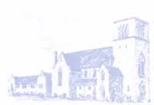
Sunday, Sept. 11

RALLY DAY

A TIME TO RALLY TOGETHER AFTER THE SUMMER!

We’ll all be in worship together
younger and older alike

because that’s who we are!

STAY FOR LUNCH !
Hot dogs, hamburgers, dessert and
home made French fries by Justin!!
(with thanks to the CD & Membership committees)

Come and catch up. Share

‘WHERE IN THE WORLD’
you’ve been this summer, as we look forward
to Church School and Nursery
beginning next Sunday, Sept. 18!

**************************************

CHURCH SCHOOL BEGINS
Sunday, September 18!
The teachers look forward to welcoming
the children and young people back to Church School.

Every week the teachers will present a different
Bible story to the children, while relating it to something familiar
to the children, in today’s world.

We have extremely creative teachers, who will have amazing crafts
to go with the theme every week!

For High School Youth, leader Chris Ross is inviting those
new to Gr. 9 - to join with the other high ‘schoolers’
Sunday, October 2 in the library.
Start off in the sanctuary, and leave with the group
when the children leave for Church School.

THANKSGIVING SUNDAY
God has blessed us, as a community of faith,
that we may be a blessing to others.

Once again, we invite you to bring
GIFTS OF HEALTHY FOOD
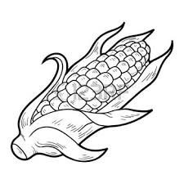
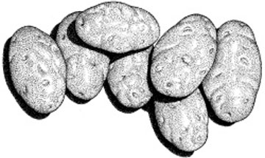
for those who do not have enough!

From the fields & orchards:
Potatoes, squash, turnip, brussel sprouts, apples,
beets, cabbage, carrots, oranges, onions, corn on the cob.
(foods with a little staying power)

From the grocery store:
Healthy canned goods (low sodium),

spaghetti & tomato sauce, beans, lentils, tuna, salmon, soup,
juices, mac & cheese, peanut butter, coffee, tea, sugar, crackers

peanut butter, dry pasta, rice, salt, pepper,
Cereal and hot cereal, granola bars, etc. for lunches,
garbage bags, saran wrap, sandwich bags.

Personal Hygiene Products:

Tooth Paste, dental floss, hand soap, shampoo, conditioner, deodorants sans aluminum, dish soap, laundry detergent, toilet tissue, razors, diapers, baby lotion, and

Women’s Hygiene Products

“THANKSGIVING, AFTERALL, IS A WORD OF ACTION”

W.J. Cameron


DOORS OPEN ST. THOMAS

Are there any buildings in St. Thomas that have
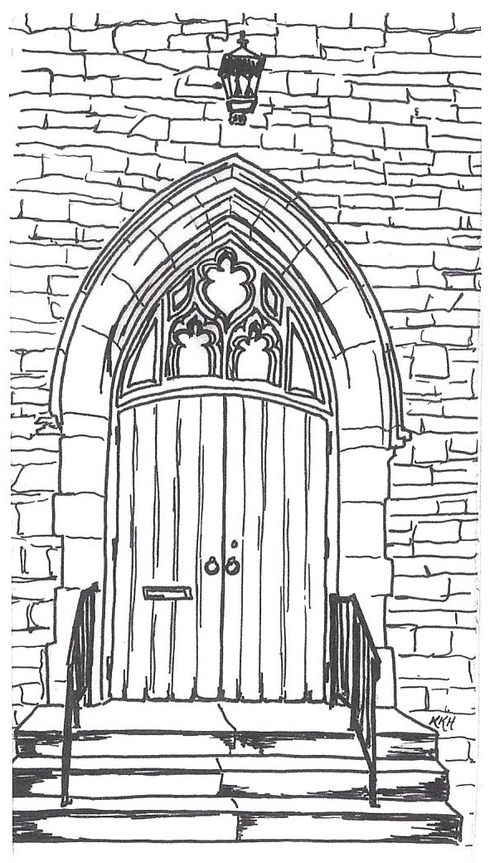
interested you, and yet you’ve never been inside?

Chances are there are those who have passed by our beautiful stone church, wondering what it’s like inside?

DOORS OPEN
is an invitation to ‘Come inside and Look Around’.

We are excited to share with you, that FIRST UNITED CHURCH is on the list of buildings OPEN Saturday, October 15th.

Stay tuned for further details!
However, if you would like to help welcome Visitors touring First Church on Saturday, October 15th give Edith Nimmo a call at 631-7794 to volunteer.
(we don’t want anyone to get lost –
or feel alone anywhere in the building.)

FIRST CHURCH’S BOSTON PIZZA NIGHT
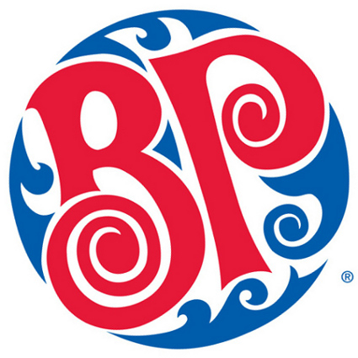
Mon. Oct. 17, 5:30 – 7:00pm

A great ‘fun’raiser for the church.
Cost is $20 per person –
but $10 of that comes back to the church.
An opportunity to visit and best of all – NO CLEAN UP!

THE BUFFET includes: Pizza, Pasta and Caesar Salad
(drinks not included)
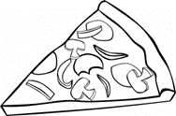
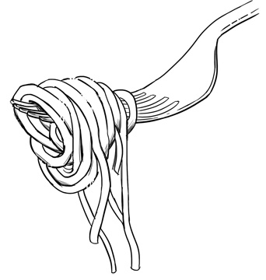
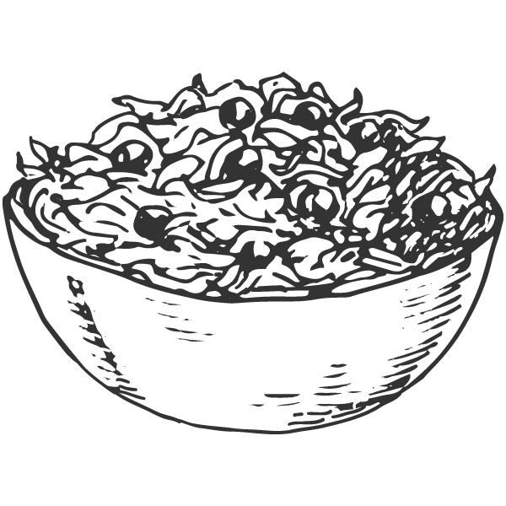

DOOR PRIZES too!
Be sure to write your name on the back of the ticket
before you turn it in at the restaurant.
Tickets will be drawn that night!
Children can order from the ‘Children’s menu”
instead of paying $20 for each child.

