First United Church
Seeking to be a welcoming community of Christian faith, proclaiming and celebrating the love of God in Jesus Christ through the Inspiration of the Holy Spirit

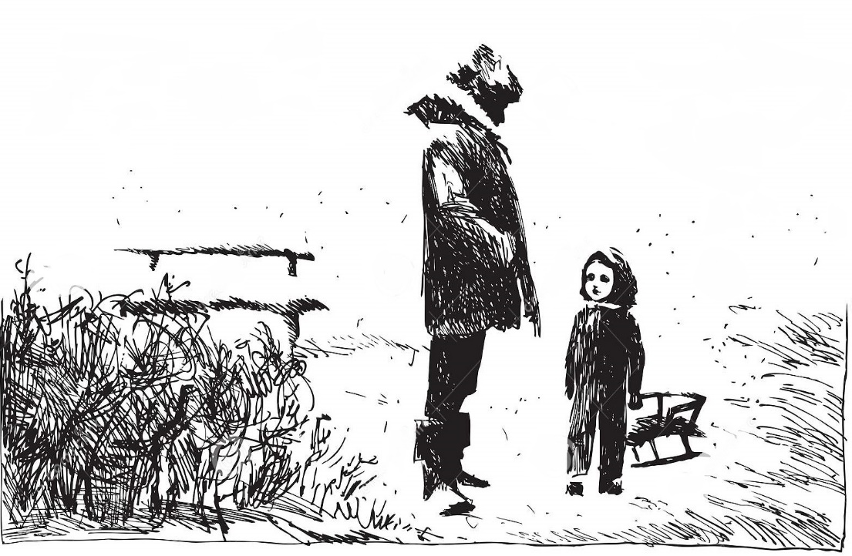

Advent 4
December 22, 2019 @ 10:30am

Order of Service
* You are invited to stand if comfortable doing so

VU = Voices United MV = More Voices

Musical Prelude

Welcome

Choral Musical Prelude
- VU#91 “The First Nowell”
The first Nowell the angels did say
Was to certain poor shepherds in fields as they lay;
In fields where they lay a-keeping their sheep
On a cold winter’s night that was so deep.
Nowell, Nowell, Nowell, Nowell,
Born is the King of Israel.

- VU#73 “The Virgin Mary Had a Baby Boy”
The virgin Mary had a baby boy,
the virgin Mary had a baby boy,
The virgin Mary had a baby boy,
and they say that his name is Jesus.
He come from the glory, He come from the glorious kingdom.
He come from the glory, He come from the glorious kingdom. Oh yes! Believer! Oh yes! Believer!
He come from glory, he come from the glorious kingdom.

Call to Worship
We have been gathering our lives around this advent wreath.
We have prepared and have been bringing them to burn.
The old flames of hope, peace, and joy have been kindled.
Now it is time to light the candle of love.
We see the candle of love ready to come to flame,
and in so doing we risk the invitation of love to heal us into life.

Love’s vaulted ceiling is like that of a cathedral;
Holding together many voices, giving it space to be one song.
Love is attraction and creativity, synergy and collective desire,
It is present in birth and in death.
Love is none other than the force which goads creation,
And always has been.
Loving flame, set us ablaze and we will be known as the family of God. (Third blue candle is lit)

Sing: “I am walking a path of Love, I am walking a path of Love,
I am walking a path of Love, lead me home, lead me home.”

Opening Prayer
Breathlessly we gather, O God,
to see what you will do.
From hilltops and caravan routes,
from side street and electronic highways,
we hear your music in the air.
Where is the warrior who will win the struggle of all your people
for true wealth, true community, true love?
Where is the wise judge who will rule in fairness
on behalf of all the downtrodden?
Can we believe our senses, O God?
Have you taken leave of yours?
Strengthen our faith, Holy One,
to accept this infant, this youth, this rejected one,
As your warrior of love, our judge, and our hope. (Robin Wardlaw)

Passing of the Peace
Sing: Halle, Halle, Halle, lu jah! Halle, Halle, Halle, lu jah!
Halle, Halle, Halle, lu jah! Halle lu jah! (clap) Halle lu jah!

Life and Work of the Church

Pageant

Hymn: VU#43 “Go Tell It On The Mountain” (chorus only)
Go, tell it on the mountain, over the hills and everywhere.
Go tell it on the mountain that Jesus Christ is born. (2x)

Prayer/The Lord’s Prayer

Offering Ourselves, Tithes & Gifts: Rachel Gorman

Dedication Hymn: (tune “Eidelweiss”)
God of LOVE, hear our prayer. Bless this offering we bring you.
May our lives do Your will; guide and guard us forever.
Give us courage to stand for truth; help us give to others.
God of LOVE, hear our prayer, Bless this offering we bring you.

Scripture Readings: Matthew 1:18-25

The Message: “Such a Love that Starts a Fire” Rev. Daryl Webber

Liturgy of Remembrance and Lights
(people are invited to come forward and light a candle in the name of those they are thinking about this Season. Take your time, come forward speak the name of whisper as you light a candle)
Lighting the Candles of Compassion and Community
Wisdom
Faith

Hymn: VU#9 “People Look East”

*Commissioning/ Benediction
Closing - Sing: VU#33 “Jesus Came Bringing Us Love” (2x)
Jesus came bringing us love, Jesus came bringing us love,
Jesus came bringing us love, hallelujah forever more!

Musical Postlude

The Life & Work of the Church – December 22
We invite you to join us refreshments in the
Fellowship Room following worship.

*Looking for Board Members:
The church requires many hours of volunteer work to make it run smoothly. If you are able to serve or know of someone who would be good to serve on our Official Board please talk to an existing member of the Board, or Lori in the church office

*At First we love having a time of Fellowship after Worship on Sundays!
It’s a time to greet friends, new and old, over a drink & maybe a goody!! If this is something you would enjoy hosting, you are invited to sign up on the sheet in the Fellowship Room (Drinks supplied – coffee would just need to be put on in the morning!). We’d love to have you!

*Would you be willing to participate or lead the worship service? If so please speak to Rev. Daryl, Richard Auckland or one of the worship team leaders.

Happy birthday to: Sara Turner.

This week:

Tuesday - *Christmas Eve Service with Communion @ 7pm

We need your help to know who is sick, in hospital
or just wishing a visit. Please let Lori know in the
Church Office at 519-631-7570 ext 21. Thank you!

FROM THE CHURCH OFFICE …..
Lori is on holidays from Friday, December 20 to Monday, January 6 inclusive. If you would like to make a DONATION FOR THE YEAR 2019 – please place it through the Curtis Street mail slot, slip it under my Office Door or mail it to the Church. You may come in on Tuesday, January 7 if you would like to see me in person. The final deposit for 2019 Givings will be made at 3pm on Tuesday, January 7. Donations received after this time will be credited to your 2020 Givings. Best wishes, Lori

A Note from Lori & the Finance Committee
The 2020 Offering envelopes are ready for pickup in the Library.
(Please don’t use them until January )
IMPORTANT: Please note – ALL Numbers have changed!
To reduce costs and save trees we have done a complete overhaul of the numbering of our offering envelopes for 2020! We reduced the number of sets given out (removed those who didn’t use / or didn’t pick up their envelopes resulting in them being thrown out at year end) – and we were able to reduce our numbers by 200 sets!!! BIG SAVINGS! Over $400! )
PLEASE DO NOT USE ANY OLD ENVELOPES OR ENVELOPE NUMBERS AFTER DECEMBER 31, 2019! Doing so could cause your offering to be inadvertently credited to another person.
If you go to pick up a set of envelopes and there isn’t one there with your name on it, please contact Lori in the office and she can arrange to get you a set.
We are hoping to only distribute envelopes to those who use them on a regular basis. If you give monthly, quarterly, annually, etc. (that’s great – no problem!) – you have been assigned a number that does not have actual envelopes but your offerings will be credited to it. Just place your cheque on the offering plate (or in a plain envelope if you’d prefer) and we’ll look after it! If you’d like to KNOW the number you’ve been assigned to write it on your cheque/blank envelope, Lori can give you that information. Thank you so much for your co-operation as we go through this numbering transition!!

7 Curtis St., St. Thomas, ON N5P 1H3
Phone: (519) 631-7570
e-mail: office@1stunitedchurch.ca
web: www.1stunitedchurch.ca
MINISTERS: ALL THE PEOPLE OF GOD
Intentional Interim Minister: Rev. Daryl Webber
Music Minister: Jody McDonald-Groulx
Secretary/Treasurer: Lori Hoffman
Custodian: Dave Luftenegger

