First United Church
Seeking to be a welcoming community of Christian faith, proclaiming and celebrating the love of God in Jesus Christ through the Inspiration of the Holy Spirit

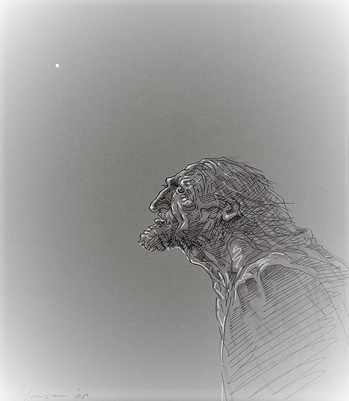

What did you go into the desert to see?
Did you expect to see a reed blowing around in the wind? A prophet? Yes. Yes, a prophet and more than a prophet.
When you saw John, you saw the one whom the prophet
Malachi envisioned… Matthew 11:7-10

December 15, 2019 @ 10:30am

Order of Service
* You are invited to stand if comfortable doing so

VU = Voices United MV = More Voices

Musical Prelude

Welcome

Choral Musical Prelude
- MV#40 “Never Ending Joy” (2x)
Never ending joy, never ending joy, never ending joy,
Never ending joy, never ending joy, never ending joy!

- “Feliz Navidad” (3x)
Feliz Navidad, Feliz Navidad
Feliz Navidad, prospero ano y felicidad.
Feliz Navidad, Feliz Navidad
Feliz Navidad, prospero ano y felicidad.
I want to wish you a Merry Christmas,
I want to wish you a Merry Christmas,
I want to wish you a Merry Christmas,
From the bottom of my heart.

Call to Worship
One: Let us continue our journey into the world with our God,
All: where we will be shown how to rebuild shattered hearts
with hope.
One: Let us continue by gathering in Worship together
To be strengthened as Jesus was strengthened,
All: so we will mend brokenness with love,
and joy shall be seeded and bloom like the crocus.
One: Let us surrender our hearts to the Spirit,
All: so we may be with those
who wait to be released into the fullness of Life.
One: Let us continue our journey together. (Daryl Webber, 2019)

Opening Prayer
One: O God of Eternal Delight, you reside precisely at our core.
Even while our sorrows, grief and yearning spill into anger,
While our rutted roads of depression and burnout cloak
our character,
and there upon the threshold of our old mind,
shame humiliates us again,
All: We trust that you, O God of Joy, are present in all moments.
One: When we feel we are very much alone,
Remind us that You are older in us than the skin of our sorrow,
That you love us beyond our oldest reasoning,
and it is Creator’s desire to infuse us with a mysterious joy that
baffles every judgement.
All: Such is your joy, O God.
Such is the Hallmark of our faith.
One: Even when our greatest earthly happiness is unsatisfying,
A fullness in life you awaken us to.
All: In your name, Great God of Delight, who stirs us with joy,
Call us once again to be your children. Amen. (Daryl Webber, 2019)

Passing of the Peace
Sing: Halle, Halle, Halle, lu jah! Halle, Halle, Halle, lu jah!
Halle, Halle, Halle, lu jah! Halle lu jah! (clap) Halle lu jah!

Musical Offering: Senior Choir

Life and Work of the Church

Lighting the Advent Candle of Joy:
Joy lures us in each day
to the primal region of delight… the earth.
Earth is the charity of the divine,
and if ever our flesh was given to discern the bountiful offering,
balance in life would be reclaimed;
and the flame of joy, long needed now, would renew us at last.
Bright candle of joy, unveiling the depth of life,
ravish us with your light. (Pink candle of JOY is lit)

Sing: “I am walking a path of Joy, I am walking a path of Joy,
I am walking a path of Joy, lead me home, lead me home.”

Conversation with the Young People Children/Youth may go to Church School

Prayer/The Lord’s Prayer

Hymn: VU#29 “Hark the Glad Sound”

Offering Ourselves, Tithes & Gifts

Dedication Hymn: (tune “Eidelweiss”)
God of JOY, hear our prayer. Bless this offering we bring you.
May our lives do Your will; guide and guard us forever.
Give us courage to stand for truth; help us give to others.
God of JOY, hear our prayer, Bless this offering we bring you.

Scripture Readings: Isaiah 35:1-10; Matthew 11:2-11

The Message: “Joy. The Maker of New Narratives” Rev. Daryl Webber

Hymn: VU#59 “Joy to the World”

*Commissioning/ Benediction
Closing - Sing: VU#33 “Jesus Came Bringing Us Joy” (2x)
Jesus came bringing us joy, Jesus came bringing us joy,
Jesus came bringing us joy, hallelujah forever more!

Musical Postlude

Thank you to Dr. Wayne Carroll
for sharing his musical gifts this morning.
The Life & Work of the Church – December 15
We invite you to join us refreshments in the
Fellowship Room following worship.

Thank you to everyone who assisted with the Quarter Auction on December 4th. Over $1,400 was raised!!

Looking for Board Members:
The church requires many hours of volunteer work to make it run smoothly. If you are able to serve or know of someone who would be good to serve on our Official Board please talk to an existing member of the Board, or Lori in the church office

At First we love having a time of Fellowship after Worship on Sundays!
It’s a time to greet friends, new and old, over a drink & maybe a goody!! If this is something you would enjoy hosting, you are invited to sign up on the sheet in the Fellowship Room (Drinks supplied – coffee would just need to be put on in the morning!). We’d love to have you!

Would you be willing to participate or lead the worship service? If so please speak to Rev. Daryl, Richard Auckland or one of the worship team leaders.

Happy birthday to: Carol Gagen, Bob Fellows, Maureen Turner, Bill Beamish.

This week:

Tuesday - *EarlyON Playgroup 9:30-11:30am in the Assembly Hall

*Youth Group – 7:00-8:15pm. For grades 5-12. All welcome!

Thursday - *Pathfinders – @7:00pm in the Gym/Room 3
*Senior Choir practice @ 7:30pm

Next Sunday, December 22 – Advent 4 – Children’s Pageant During Worship! Costumes will be out that day! All are welcome to participate!

Upcoming Dates / Events
Tuesday, December 24 @ 7pm – Christmas Eve Worship Service with Communion
We need your help to know who is sick, in hospital
or just wishing a visit. Please let Lori know in the
Church Office at 519-631-7570 ext 21. Thank you!

A Note from Lori & the Finance Committee
The 2020 Offering envelopes are ready for pickup in the Library.
(Please don’t use them until January )
IMPORTANT: Please note – ALL Numbers have changed!
To reduce costs and save trees we have done a complete overhaul of the numbering of our offering envelopes for 2020! We reduced the number of sets given out (removed those who didn’t use / or didn’t pick up their envelopes resulting in them being thrown out at year end) – and we were able to reduce our numbers by 200 sets!!! BIG SAVINGS! Over $400! )
PLEASE DO NOT USE ANY OLD ENVELOPES OR ENVELOPE NUMBERS AFTER DECEMBER 31, 2019! Doing so could cause your offering to be inadvertently credited to another person.
If you go to pick up a set of envelopes and there isn’t one there with your name on it, please contact Lori in the office and she can arrange to get you a set.
We are hoping to only distribute envelopes to those who use them on a regular basis. If you give monthly, quarterly, annually, etc. (that’s great – no problem!) – you have been assigned a number that does not have actual envelopes but your offerings will be credited to it. Just place your cheque on the offering plate (or in a plain envelope if you’d prefer) and we’ll look after it! If you’d like to KNOW the number you’ve been assigned to write it on your cheque/blank envelope, Lori can give you that information. Thank you so much for your co-operation as we go through this numbering transition!!

FROM THE CHURCH OFFICE …..
Lori is on holidays from Friday, December 20 to Monday, January 6 inclusive. If you would like to make a DONATION FOR THE YEAR 2019 – please place it through the Curtis Street mail slot, slip it under my Office Door or mail it to the Church. You may come in on Tuesday, January 7 if you would like to see me in person. The final deposit for 2019 Givings will be made at 3pm on Tuesday, January 7. Donations received after this time will be credited to your 2020 Givings. Best wishes, Lori

7 Curtis St., St. Thomas, ON N5P 1H3
Phone: (519) 631-7570
e-mail: office@1stunitedchurch.ca
web: www.1stunitedchurch.ca
MINISTERS: ALL THE PEOPLE OF GOD
Intentional Interim Minister: Rev. Daryl Webber
Music Minister: Jody McDonald-Groulx
Secretary/Treasurer: Lori Hoffman
Custodian: Dave Luftenegger

