First United Church
Seeking to be a welcoming community of Christian faith, proclaiming and celebrating the love of God in Jesus Christ through the Inspiration of the Holy Spirit

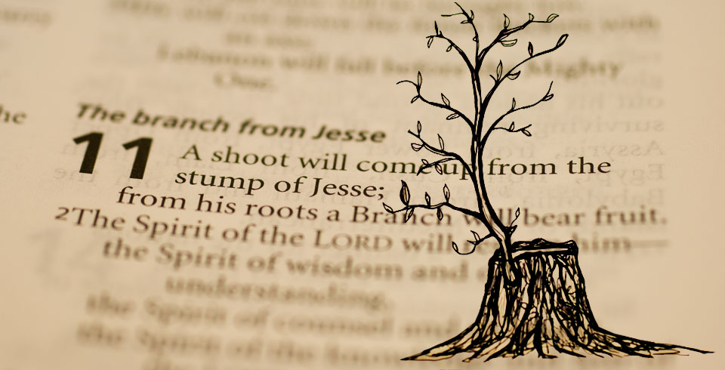

December 8, 2019 @ 10:30am

7 Curtis St., St.Thomas, ON N5P 1H3 Phone: (519) 631-7570
e-mail: office@1stunitedchurch.ca
web: www.1stunitedchurch.ca
MINISTERS: ALL THE PEOPLE OF GOD
Intentional Interim Minister: Rev. Daryl Webber
Music Minister: Jody McDonald-Groulx
Secretary/Treasurer: Lori Hoffman
Custodian: Dave Luftenegger

Order of Service
* You are invited to stand if comfortable doing so

VU = Voices United MV = More Voices

Musical Prelude: The Lushers
Welcome
Choral Musical Prelude
- “I Am Becoming Peace” Linnea Good (2x)
I am becoming peace. I am becoming Peace.
A well of patience, well of grace,
make my soul a holy place.
I am becoming peace.

- VU#381 “Spirit of Life” (2x)
Spirit of Life, come unto me.
Sing in my heart all the stirrings of compassion.
Blow in the wind, rise in the sea;
Move in the hand, giving life the shape of justice.
Roots hold me close; wings set me free;
Spirit of Life, come to me, come to me.

Call to Worship
All: Somewhere on the edge of field is a stump.
One: A crumbling and cut off
Decaying and desolate
Forgotten and left to its own fate
Old stump.
All: The edges of the stump hold its story.
One: A memory of its last summer and its strength
Its towering height and branches of hope
Its fall and its story of how it became a forgotten
Old stump.
All: The Mighty Spirit, making pilgrimage rested before the old stump.
One: Without judging by what eyes can evaluate,
Or deciding by what stories the ears may overhear
Nor assuming what the rotting stump thought of its rotten self,
The Spirit revelled in the moment gifted to her before
the old stump.
All: It seemed so good to be before such a discarded and dismissed
old stump!
One: Seemed good that the Spirit of the Lord should rest here:
That the spirit of wisdom and understanding would reside
in such mean estate.
That the spirit of counsel and might would grace this dreary
landscape.
Now, the Lord’s delight moved there with an “other-world”
regard for the old stump.
All: The prophet Isaiah announced it long ago regarding
an old stump,
One: that a bud and then a branch would emerge,
that the poor and privileged would love equity,
that the people would remember to pause
so as to learn to speak of healing,
and announced that every old stump the nations
stumbled over would hold God’s design.
All: We gather in the Great Spirit’s regard for life.
We gather before Creator’s power. (Daryl Webber, 2019)

Opening Prayer
Emmanuel, here are our swords,
Turn them into plowshares.
Here is our labour,
Turn it into blessings.
Here is our Sabbath morning,
Turn the day of rest into a time of creativity.
Here are our hearts,
Turn them to flesh
So that we may ache with an aching world
And love so widely that none are left out. Amen

Passing of the Peace
Sing: Halle, Halle, Halle, lu jah! Halle, Halle, Halle, lu jah!
Halle, Halle, Halle, lu jah! Halle lu jah! (clap) Halle lu jah!

Musical Offering: Senior Choir

Life and Work of the Church
Lighting the Advent Candle of Peace: Brenda & Wayne Smith
Whispering peace blows on our old and wounded minds and hearts;
leaning in with an invitation to re-open, to heal,
to expand, to integrate.
Peace pries in like incense –
like the residue of sages and activists already lingering in this room.
Peace pries yet remains elusive.
Were we to quiet ourselves before teachers who have learned from
the voice of peace,
our hearts and minds and those of our children would become
part of the greatest revolution ever.
Bright light of peace, would you lure us in this season
to sit close to your fire. (Candle of Peace is lit)

Sing: “I am walking a path of Peace,
I am walking a path of Peace,
I am walking a path of Peace,
lead me home, lead me home.”

Conversation with the Young People:
Children/Youth may go to Church School

Prayer/The Lord’s Prayer

Hymn: VU#64 “O Little Town of Bethlehem: (v 1, 2)
- O little town of Bethlehem,
how still we see thee lie!
Above thy deep and dreamless sleep
the silent stars go by;
yet in thy dark streets shineth
the everlasting light;
the hopes and fears of all the years
are met in thee tonight.

- For Christ is born of Mary;
and gathered all above,
while mortals sleep, the angels keep
their watch of wondering love.
O morning stars, together
proclaim the holy birth,
and praises sing to God the King,
and peace to all on earth.

Offering Ourselves, Tithes & Gifts: The Lushers

Dedication Hymn: (tune “Eidelweiss”)
God of PEACE, hear our prayer. Bless this offering we bring you. May our lives do Your will; guide and guard us forever. Give us courage to stand for truth; help us give to others. God of PEACE, hear our prayer, Bless this offering we bring you.

Scripture Readings: Isaiah 11:1-10
Matthew 3:1-12

The Message: “Peace Pries In” Rev. Daryl Webber

Hymn: MV#79 “Spirit, Open My Heart”

*Commissioning/ Benediction
Closing - Sing: VU#33 “Jesus Came Bringing Us Peace” (2x)
Jesus came bringing us peace, Jesus came bringing us peace,
Jesus came bringing us peace, hallelujah forever more!

* Musical Postlude
Special thanks to the Lushers for sharing their musical gifts!
The Life & Work of the Church – December 8
We invite you to join us refreshments in the Fellowship Room following

Thank you! Last week $116.10 was contributed to the
Youth Group’s Hot Chocolate “Pay What You Can” basket!!
The proceeds will be used for Youth Outreach Programs!

Proceeds from the Lessons & Carols Choral Celebration
last Sunday evening resulted in $895.40 being donated
to the St. Thomas Elgin Food Bank!

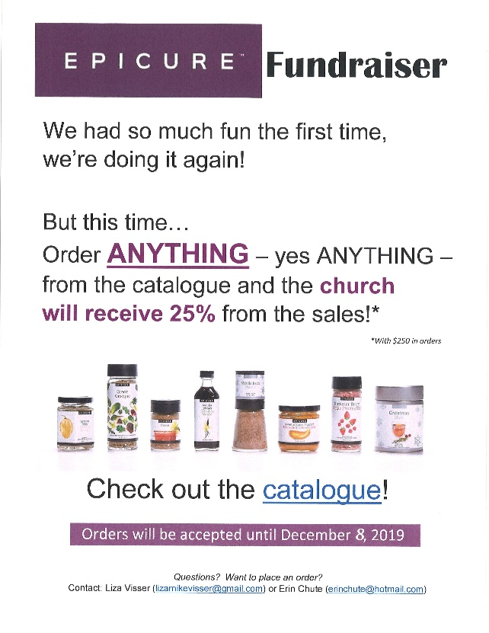

Epicure Fundraising
Order Deadline is TODAY!
Please see Erin Chute
or Liza Visser to order!

Looking for Board Members:
The church requires many hours of volunteer work to make it run smoothly. If you are able to serve or know of someone who would be good to serve on our Official Board please talk to an existing member of the Board, or Lori in the church office

At First we love having a time of Fellowship after Worship on Sundays!
It’s a time to greet friends, new and old, over a drink & maybe a goody!! If this is something you would enjoy hosting, you are invited to sign up on the sheet in the Fellowship Room (Drinks supplied – coffee would just need to be put on in the morning!). We’d love to have you!

Happy birthday to: Noel MacKay, Janis Bennell, Dave Copeland, Joseph Muma.

Rosemary Underhill has made up some "Porch Pots" of various sizes filled with cedar, fir, white pine, dogwood and red pine boughs. The "Greenery" is in the pots and there is "bling" available for you to insert and customize your own arrangement! These "Porch Pots" are available now and can be obtained at 42665 Southdale Line (pots are in the driveway on tables near the garage but the extra "bling" is in the garage which she is going to leave open for First Church people for the next few days – pick up anytime). The cost is a donation to First United Church (please mark it "Porch Pots"). Thank you to Rosemary for using her many talents to give us all beautiful arrangements while also donating to the Church!

This week:

Tuesday - *EarlyON Playgroup 9:30-11:30am in the Assembly Hall

*Youth Group – 7:00-8:15pm. For grades 5-12. All welcome!
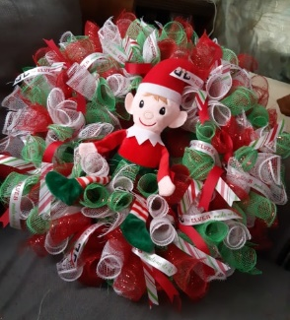
Wednesday - * Wreath Making Night
Hosted by: Liza Visser
Wednesday, December 11th @ 7:00 p.m.
Cost: $40 (includes all supplies and an elf)
($20 from each wreath will be donated
to the church)! RSVP by December 6th to
Liza: lizamikevisser@gmail.com
12 spots available-

Thursday - *Pathfinders – @7:00pm in the Gym/Room 3
*Senior Choir practice @ 7:30pm

Upcoming Dates / Events

Sunday, December 22 – Advent 4 – Children’s Pageant During Worship!

Costumes will be out that day! All are welcome to participate!

We need your help to know who is sick, in hospital
or just wishing a visit. Please let Lori know in the
Church Office at 519-631-7570 ext 21. Thank you!

A Note from Lori & the Finance Committee
The 2020 Offering envelopes are ready for pickup in the Library.
(Please don’t use them until January )
IMPORTANT: Please note – ALL Numbers have changed!
To reduce costs and save trees we have done a complete overhaul of the numbering of our offering envelopes for 2020! We reduced the number of sets given out (removed those who didn’t use / or didn’t pick up their envelopes resulting in them being thrown out at year end) – and we were able to reduce our numbers by 200 sets!!! BIG SAVINGS! Over $400! )
PLEASE DO NOT USE ANY OLD ENVELOPES OR ENVELOPE NUMBERS AFTER DECEMBER 31, 2019! Doing so could cause your offering to be inadvertently credited to another person.
If you go to pick up a set of envelopes and there isn’t one there with your name on it, please contact Lori in the office and she can arrange to get you a set.
We are hoping to only distribute envelopes to those who use them on a regular basis. If you give monthly, quarterly, annually, etc. (that’s great – no problem!) – you have been assigned a number that does not have actual envelopes but your offerings will be credited to it. Just place your cheque on the offering plate (or in a plain envelope if you’d prefer) and we’ll look after it! If you’d like to KNOW the number you’ve been assigned to write it on your cheque/blank envelope, Lori can give you that information. Thank you so much for your co-operation as we go through this numbering transition!!

