First United Church
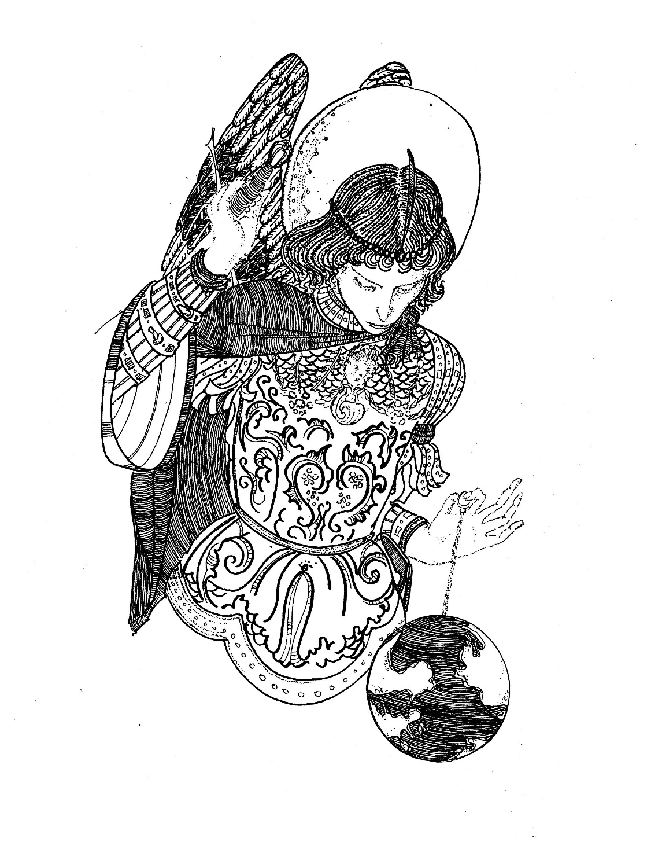
Seeking to be a welcoming community of Christian faith, proclaiming and celebrating the love of God in Jesus Christ through the Inspiration of the Holy Spirit

He will establish and uphold it with justice and righteousness from this time onward. Isaiah 9:7

December 1, 2019 @ 10:30am

First Sunday in Advent
* You are invited to stand if comfortable doing so

VU = Voices United MV = More Voices

Musical Prelude

Welcome/Life and Work of the Church

Choral Prelude
- “Deck the Halls” (2x)
Deck the halls with boughs of holly, Fa la la la la, la la la la
‘Tis the season to be jolly, Fa la la la la, la la la la
Don we now our gay apparel, Fa la la, fa la la, la la la
Troll the ancient yuletide carol, Fa la la la la, la la la la!

- VU#82 “A Light is Gleaming” (2x)
A light is gleaming, spreading its arms throughout the night,
living in the light.
Come share its gladness, God’s radiant love is burning bright,
living in the light.

Call to Worship
One: Spirit rises in every moment of eternity
to walk the pine forest
and move across the floor of the garden.
All: She prunes a clearing:
she carves out a living space,
she carpets consecrated ground with the boughs.
One: Beneath the higher limbs of the evergreen.
Spirit issues an invitation to gather upon a Holy intention.
All: O, see her desire gathering as we gather in!
One: The Spirit’s pilgrimage and this, our moment,
meet around these boughs.
All: What life we have together
is assembled and adorned with a great gift;
the gift is the communion of friends,
and the Christ who reigns between us.
One: In this clearing let us gather! (Daryl Webber, 2015)

Passing of the Peace
Sing: Halle, Halle, Halle, lu jah! Halle, Halle, Halle, lu jah!
Halle, Halle, Halle, lu jah! Halle lu jah! (clap) Halle lu jah!
Musical Offering: Senior Choir

Prayer/The Lord’s Prayer

Hymn: VU#7 “Hope is a Star” (2x)
Hope is star that shine in the night,
leading us on till the morning is bright.
When God is a child there’s joy in our song.
The last shall be first and the weak shall be strong,
and none shall be afraid.

Offering Ourselves, Tithes & Gifts
Dedication Hymn: (tune “Eidelweiss”)
God of HOPE, hear our prayer. Bless this offering we bring you.
May our lives do Your will; guide and guard us forever.
Give us courage to stand for truth; help us give to others.
God of HOPE, hear our prayer, Bless this offering we bring you.

Prayer Over Our Work as a Community
One: Great Christ,
we gather on the threshold of Advent
and we prepare to enter a New Christian Year.
All: The seasons turn and culminate this morning
and we mark this moment
with friends fashioning the tree and wreath of evergreen
with friends adorning them with bulbs,
lights, berries, pinecones and candles,
with friends moving and working together.
This ritual of adorning these
is symbolic of our life together.
We are born and are shaped by the rituals we keep.
We risk moving, helping, participating, creating, and such
activity bears fruit.
We make room for each other, do simple things together,
honour each other’s pace,
and in such a rhythm everything that seems so common
Takes on the element of all that is Holy.
One: Grant us your presence, and bind us to each other as we work
and walk together this day.
Indeed, O Lord, may this ritual be the pattern
of every sacred day.
In Jesus name we pray.
Decorating the Christmas Tree & Advent Wreath

Hymn: MV#220 “Hope Shines as the Solitary Star” (2x)
Hope shines as the solitary star. Faith is the inner light.
You and I together mirror the Light of the Lights
and illumine the pathway home.

Scripture Reading: Isaiah 9:1-7

Lighting the Christmas Tree – The Visser Family
O Christmas Tree, O Christmas Tree, Thy beauty everlasting
O Christmas Tree, O Christmas Tree, Thy beauty everlasting
Just like the life God promised us
Through Jesus Christ, God’s newborn Son
O Christmas Tree, O Christmas Tree, Thy beauty everlasting

Placing of Advent Candles
We gather our lives around this Advent Wreath,
Preparing for the old flames of hope, peace, joy and love,
to be kindled through the seasons of Advent.
We prepare them and thus risk changed lives
when their flames come to burn in us.

Reader 1: Kaitlyn Bosveld
Whispering peace blows on our old and wounded minds and hearts;
leaning in with an invitation to re-open, to heal,
to expand, to integrate.
Peace pries in like incense –
like the residue of sages and activists already lingering in this room.
Peace pries yet remains elusive.
Were we to quiet ourselves before teachers who have learned from
the voice of peace,
our hearts and minds and those of our children would become
part of the greatest revolution ever.
Bright light of peace, would you lure us in this season
to sit close to your fire. (First blue candle is placed)

Choir Chant: “I am walking a path of Peace,
I am walking a path of Peace,
I am walking a path of Peace,
lead me home, lead me home.”
Reader 2: Madison Chute
Joy lures us in each day
to the primal region of delight… the earth.
Earth is the charity of the divine,
and if ever our flesh was given to discern the bountiful offering,
balance in life would be reclaimed;
and the flame of joy, long needed now, would renew us at last.
Bright candle of joy, unveiling the depth of life,
ravish us with your light. (Pink candle is placed)

Choir Chant: “I am walking a path of Joy,
I am walking a path of Joy,
I am walking a path of Joy,
lead me home, lead me home.”

Reader 3: Teah Welch
Love’s vaulted ceiling is like that of a cathedral;
holding together many voices, giving it space to be one song.
Love is attraction and creativity, synergy and collective desire,
it is present in birth and death.
Love is none other than that force which goads creation
and always has been.
Loving flame, set us ablaze and we will be known as the family of God.
(Second blue candle is placed)

Choir Chant: “I am walking a path of Love,
I am walking a path of Love,
I am walking a path of Love,
lead me home, lead me home.”

Reader 4: Kaitlyn Bosveld
Burning hope preaches to the great liability in life –
Those so prone to sleeping through periods of great social change
and personal challenge
miss developing new attitudes and responses for our times.
Back to this ache, and into this numbness, Hope urges us along.
When Hope calls us from the future, we surely come out on fire.
Bright light of hope, become a fire in us. (Third blue candle is placed & lit)

Choir Chant: “I am walking a path of Hope,
I am walking a path of Hope,
I am walking a path of Hope,
lead me home, lead me home.”

Now the life of the Christ-child is to be kindled among us.
Jesus is light, and his life has become the light
by which Christ’s followers journey. (Centre candle is placed)

Let us present our wreaths,
symbolic of our collective life and work in Christ.
May our Advent practice prepare us to receive the Christmas babe!

Hymn: VU#59 “Joy to the World”
- Joy to the world! the Lord is come:
let earth receive her King!
Let every heart prepare him room,
and heaven and nature sing,
and heaven and nature sing,
and heaven, and heaven and nature sing.

- Joy to the world! the Savior reigns:
let all their songs employ,
while fields and floods, rocks, hills and plains,
repeat the sounding joy,
repeat the sounding joy,
repeat, repeat the sounding joy.

- No more let sins and sorrows grow,
nor thorns infest the ground:
he comes to make his blessings flow
far as the curse is found,
far as the curse is found,
far as, far as the curse is found.

- He rules the earth with truth and grace,
and makes the nations prove
the glories of his righteousness
and wonders of his love,
and wonders of his love,
and wonders, wonders of his love.
*Commissioning/ Benediction
Closing - Sing: VU#33 “Jesus Came Bringing Us Hope” (2x)
Jesus came bringing us hope, Jesus came bringing us hope,
Jesus came bringing us hope, hallelujah forever more!

* Musical Postlude

The Life & Work of the Church – December 1
We invite you to join us for Hot Chocolate hosted by the Youth Group following worship. A “pay what you can” basket will be out for donations. All proceeds will go toward Youth Outreach Programs.

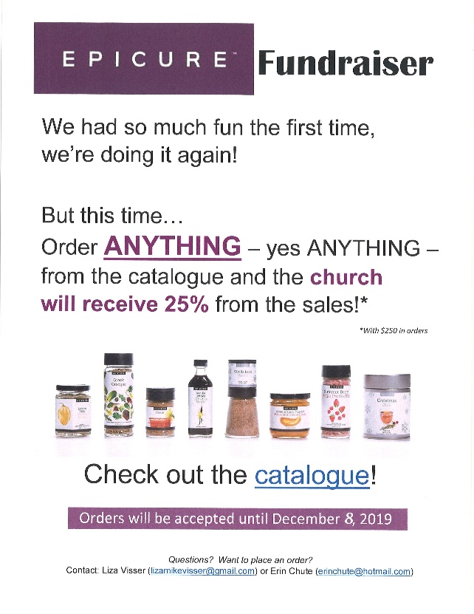

Epicure Fundraising
Order Deadline has
been EXTENDED
to next Sunday,
December 8!
Please see Erin Chute
or Liza Visser to order!

Looking for Board Members:
The church requires many hours of volunteer work to make it run smoothly. If you are able to serve or know of someone who would be good to serve on our Official Board please talk to an existing member of the Board, or Lori in the church office
At First we love having a time of Fellowship after Worship on Sundays!
It’s a time to greet friends, new and old, over a drink & maybe a goody!! If this is something you would enjoy hosting, you are invited to sign up on the sheet in the Fellowship Room (Drinks supplied – coffee would just need to be put on in the morning!). We’d love to have you!

Happy birthday to: Kaitlyn Bosveld, Teah Welch.

Rosemary Underhill has made up some "Porch Pots" of various sizes filled with cedar, fir, white pine, dogwood and red pine boughs. The "Greenery" is in the pots and there is "bling" available for you to insert and customize your own arrangement! These "Porch Pots" are available now and can be obtained at 42665 Southdale Line (pots are in the driveway on tables near the garage but the extra "bling" is in the garage which she is going to leave open for First Church people for the next few days – pick up anytime). The cost is a donation to First United Church (please mark it "Porch Pots"). Thank you to Rosemary for using her many talents to give us all beautiful arrangements while also donating to the Church!

This week:

Monday - *Christmas Shoppe using the Church Gym Monday - Friday

Tuesday - *EarlyON Playgroup 9:30-11:30am in the Assembly Hall

Wednesday - *We're hosting our first ever Quarter Auction at the church and would be happy if you could join us for the night. Doors open at 6p.m. Auction starts at 7:00 p.m.
For more info, please contact Teresa at tl.turvey@gmail.com.

Thursday - *Pathfinders – @7:00pm in the Gym/Room 3
*Senior Choir practice @ 7:30pm

Saturday: *Annual Hat and Mitt Run – Everyone welcome! Join us for a nice leisurely run/walk (5 or 10 km) a visit and of course, treats afterwards! We are asking everyone to knit hats & mitts (or buy new) to donate to local groups in need.
When & Where: Saturday, December 7 at 8 am - First United Church
Entry Fee: Hat & Mitts for local groups in need
For more info call or email Carolyn Johnson 519-318-3386 or johnsongirltris@bell.net

NEXT SUNDAY

*SECRET SANTA bags / NON-PERISHABLE FOOD ITEMS and SOCKS FOR GRACE CAFÉ are to be returned NEXT SUNDAY, December 8. There is still time to take a bag marked girl or boy and shop for a child this Christmas. Helpful Hints: Please don’t gift wrap. Feel free to buy more than one of the same gift. Our gifts will be distributed by CHRISTMAS CARE along with their annual Christmas FOOD HAMPERS. SOCKS for Grace Café. There is a huge need for Men’s, Women’s and children’s socks! Please keep these separate from your Secret Santa Bags. There will be a basket to collect your Sock donations. Our Ivor Fund supports Grace Café each year as well! Thank you for your generosity! Our gifts will be picked up by Christmas Care on Monday, December 9!
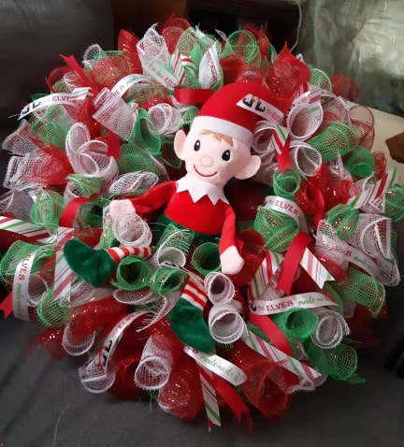

Wreath Making Night Hosted by: Liza Visser
Wednesday, December 11th @ 7:00 p.m.
Cost: $40 (includes all supplies and an elf)
($20 from each wreath will be donated
to the church)! RSVP by December 6th to
Liza: lizamikevisser@gmail.com
12 spots available-

Sunday, December 22 – Advent 4 – Children’s Pageant During Worship!

Costumes will be out that day! All are welcome to participate!

We need your help to know who is sick, in hospital
or just wishing a visit. Please let Lori know in the
Church Office at 519-631-7570 ext 21. Thank you!

From the Finance Committee
We would like to thank the congregation for a fantastic October! We brought in almost $23,000 in General Fund Givings! Thank you for your generosity & support!! Way to go First Church!!

Update
In order to meet our Financial Obligations at First Church
we need, on average and excluding fundraising, $4,400 in General Fund Givings EVERY WEEK.

Last week our General Fund Givings were $1,558

This represents a shortfall for the week of $2,842

Year to Date Update (as at October 31/19)
YTD General Fund Giving Amount Needed to Meet Obligations: $189,200

YTD Actual General Fund Givings: $106,905

This represents a YTD shortfall of $82,295

Our Current Financial Position is a Net Operating Loss of $78,648

Misc. Info
Revenue from Fundraising Projects to date: $9,948

Monthly General Fund PAR Givings $3,229

For more information, contact Don Renaud or Lori in the church office.

7 Curtis St., St.Thomas, ON N5P 1H3 Phone: (519) 631-7570
e-mail: office@1stunitedchurch.ca
web: www.1stunitedchurch.ca
MINISTERS: ALL THE PEOPLE OF GOD
Intentional Interim Minister: Rev. Daryl Webber
Music Minister: Jody McDonald-Groulx
Secretary/Treasurer: Lori Hoffman
Custodian: Dave Luftenegger

Join us TONIGHT for our
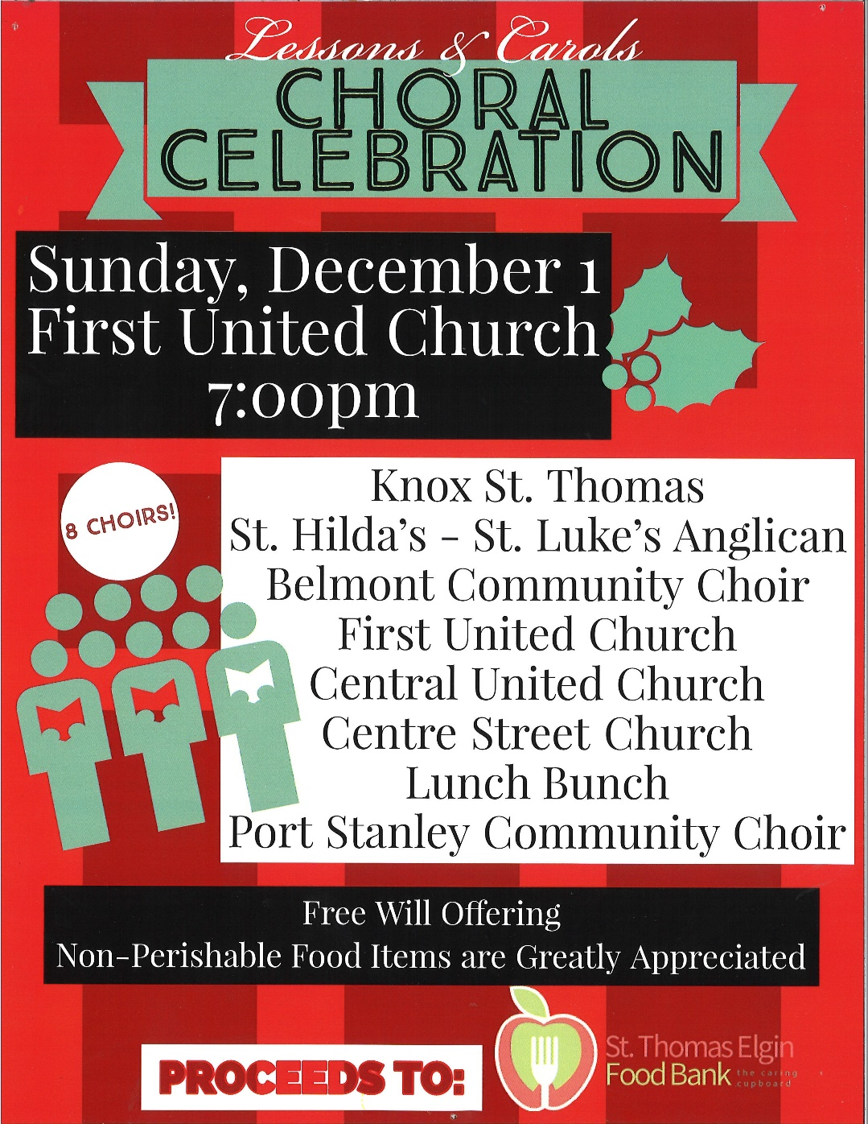
Lessons & Carols Choral Celebration!

Thank you for joining us this Advent One
to decorate our Chancel Christmas Tree!

