First United Church
Seeking to be a welcoming community of Christian faith, proclaiming and celebrating the love of God in Jesus Christ through the Inspiration of the Holy Spirit

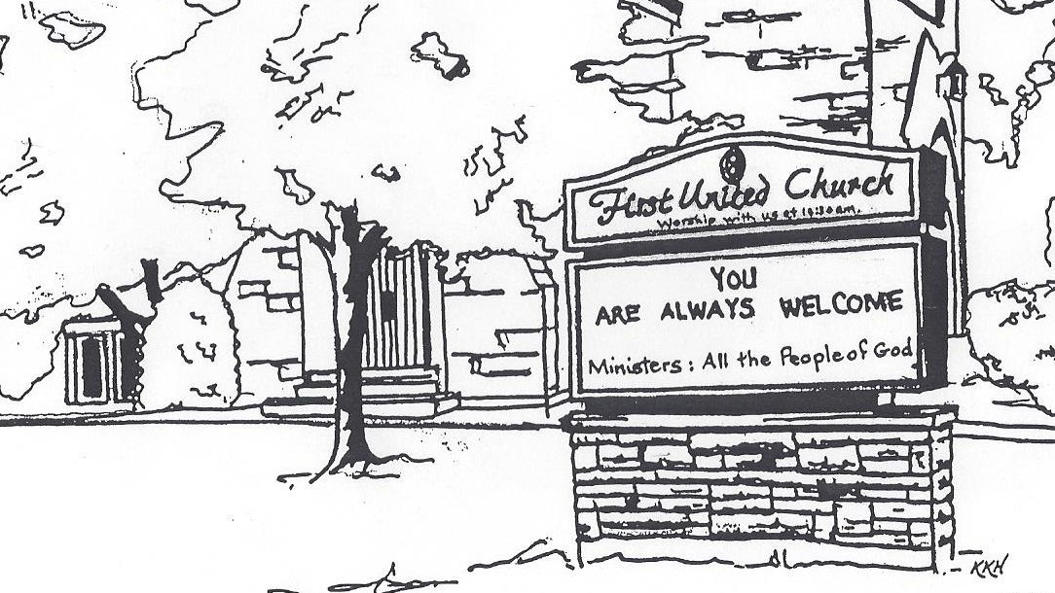

August 18, 2019 @ 10:30am

7 Curtis St., St.Thomas, ON N5P 1H3 Phone: (519) 631-7570
e-mail: office@1stunitedchurch.ca
web: www.1stunitedchurch.ca
MINISTERS: ALL THE PEOPLE OF GOD
Music Minister: Jody McDonald-Groulx
Secretary/Treasurer: Lori Hoffman
Custodian: Dave Luftenegger

Order of Service
* You are invited to stand if comfortable doing so

VU = Voices United MV = More Voices

Musical Prelude
Choral Musical Prelude: MV#7 “Gather Us In”
MV#18 “Lord Prepare Me”
Opening Prayer
Call to Worship:
One: The Creator has gathered us to this place.
All: We open our hearts to hear the word of God.
One: The Christ summons us to this place.
All: Where we can learn how to serve God without reservation or hesitation.
One: The Spirit will send us from this place.
All: Where we can put our faith into action, and be true believers and leaders of the faith through our word and deed.

Lighting of the Christ Candle
I am the light of world, you people come and follow me.
If we follow and love, we’ll learn the mystery
Of what we were meant to do and be.

Passing of the Peace (VU #958 “Halle, Halle, Halle”)
Welcome/Life and Work of the Church
Hymn of Praise: VU#424 “May the God Of Hope…”
Prayers of the People/The Lord’s Prayer
Hymn: MV#182 “Grateful” (2x) Chorus only
Conversation with the Young People
Children may leave for the Activity Room

Offering Ourselves, Tithes & Gifts
Dedication Hymn: (tune “Eidelweiss”)
God of Love, hear our prayer. Bless this offering we bring you. May our lives do Your will; guide and guard us forever. Give us courage to stand for truth; help us give to others. God of Love, hear our prayer, Bless this offering we bring you.

Scripture Reading
Hymn of Preparation: VU#660 “How Firm a Foundation”
The Message: Jamie McArthur
Hymn of Response: VU#289 “It Only Takes a Spark” vv 1 & 3
*Commissioning/ Benediction
Closing - Sing: MV #209
Go make a diff’rence. We can make a diff’rence.
Go make a diff’rence in the world.
Go make a diff’rence. We can make a diff’rence.
Go make a diff’rence in the world.

* Musical Postlude
Summer Services at First
We are pleased to welcome the following individuals to our services this summer who will share their experiences with us:
August 25 We are worshipping at the St. Thomas Christian Church at 451 Wellington. There will be a catered lunch after the service. Please sign up in the Fellowship Room if you are intending to stay for the lunch that day (just trying to get a handle on numbers). There will be a free will offering to cover the cost.
September 1 We are back at First United for the fall. Join us as we
continue to celebrate our 185th year!

The Life & Work of the Church – August 18, 2019

Thank you to Paula Thomas for sharing her
musical gifts with us today.

Future Dates / Events
Jody & her music student Hillary Tufford, are presenting a Mini-Recital on Sunday, August 25 at 3pm. All members of the congregation & their friends are welcome to attend. The Recital will feature the music of Mozart, Beethoven, Strauss, Mahler, and Weill.

Elgin Theatre Guild Fundraiser for First
On Thursday, September 26 at 7:30 PM, the Elgin Theatre Guild presents Sandy Toes and Salty Kisses at the historic Princess Ave. Playhouse. Tickets can be purchased for this date through First United Church for $20, with $8 from every ticket sold going back to the church! This is a great opportunity to invite friends, family and neighbours for a fun evening out, and raise money for First! Tickets are available through the church office. Check our website for more details

