First United Church
Seeking to be a welcoming community of Christian faith, proclaiming and celebrating the love of God in Jesus Christ through the Inspiration of the Holy Spirit

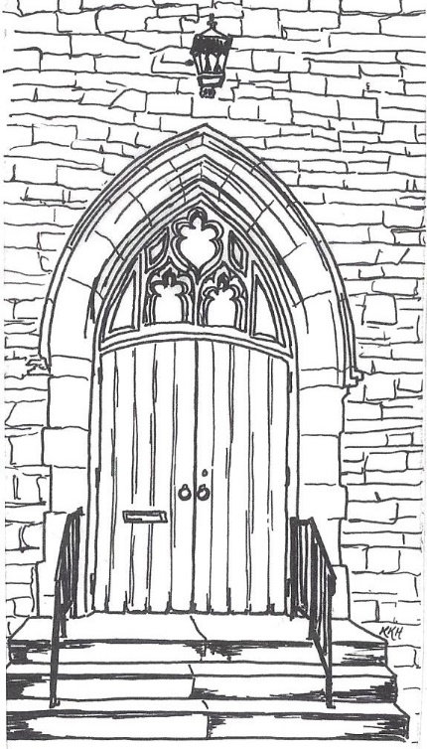

August 12, 2018 @ 10:30am

7 Curtis St., St.Thomas, ON N5P 1H3 Phone: (519) 631-7570
e-mail: office@1stunitedchurch.ca
web: www.1stunitedchurch.ca
MINISTERS: ALL THE PEOPLE OF GOD
Pastoral Minister: Rev. Emmanuel K. Ofori
Music Minister: Jody McDonald-Groulx
Secretary/Treasurer: Lori Hoffman
Custodian: Dave Luftenegger

12th Sunday of Pentecost Sunday
Worship Service
Sunday, August 12, 2018 - 10:30 a.m.
Guest Speaker: Chris Ross

Notes: Asterisk (*) – You may stand if comfortable doing so
VU = Voices United MV = More Voices

Musical/Choral Prelude
- MV#30 “It’s a Song of Praise to the Maker”
And by the Spirit you and I can join our voices to the holy cry and sing, sing, sing to the Maker too.
- MV#18 “Lord, Prepare Me…” (2x)
Lord, prepare me to be a sanctuary, pure and holy tried and true; with thanksgiving, I’ll be a living sanctuary for you.

Opening Prayer

Call to Worship (Psalm 20:6-9)
One: The Lord gives victory to his anointed.
All: He answers him from his heavenly sanctuary with the
victorious power of his right hand.
One: Some trust in chariots and some in horses,
All: but we trust in the name of the Lord our God.
One: They are brought to their knees and fall,
All: but we rise up and stand firm.
One: Lord, give victory to the king!
All: Answer us when we call!

Life and Work of the Church [see insert]

Welcoming of Visitors

Greetings: Peace of Christ (Halle, Halle, Halle)

Song of Praise: “Lord, I Lift Your Name On High” (2x)

Lord, I lift Your name on high; Lord, I love to sing Your praises.

I’m so glad You’re in my life; I’m so glad You came to save us.

You came from heaven to earth to show the way,

From the earth to the cross, my debt to pay.

From the cross to the grave, From the grave to the sky;

Lord, I lift Your name on high!

Prayer

The Lord’s Prayer

Hymn: MV#188 “I Thank You, Thank You Jesus”

The children may go to the Activity Room with Marcie Hill during the singing of the hymn

Scripture Reading: Mark 8:27-33
Reader: This is the Word of God
All: Thanks be to God

The Message: “Why Did Jesus Die?”
Offertory
Hymn of Dedication
God of Love, hear our prayer, bless this offering we bring you.
May our lives, do Your will, guide and guard us forever.
Give us courage to stand for truth, help us give to others.
God of Love, hear our prayer, bless this offering we bring you.

Offertory Prayer

*Closing Hymn: MV#42 “Praise God For This Holy Ground”
* Benediction/Sending Forth
Threefold Amen
Commissioning Hymn: MV#209 “Go Make A Diff’rence”
Go make a diff’rence, We can make a diff’rence.
Go make a diff’rence in the world.
Go make a diff’rence. We can make a diff’rence.
Go make a diff’rence in the world.

* Musical Postlude
LIFE & WORK OF THE CHURCH
August 12, 2018

Rev. Emmanuel Ofori is on vacation for the month of August.
Rev. John Brown will be covering for Pastoral Emergencies.
If you have a Pastoral Emergency, please call Rev. Brown @ 519-633-3894.
(Lori is on vacation this week.)

Happy birthday to: Emily Apfelbeck, Riley Apfelbeck, Curtis Apfelbeck, Carlene MacMenamin, Cameron Scott, Justin Chute.

Happy anniversary to: Ray & Lisa Bosveld.

TODAY: *Faith Activity Room for children 4 & up in the
Music Room.

*Join us in the Fellowship Room for refreshments following
the worship service!

Upcoming Dates & Events
If you’d like to volunteer to serve Summer Lemonade in the
Fellowship Room following Sunday worship please call Ruth
Zions @ 226-289-3055.

Don’t forget to register for Vacation Bible Camp!!
There are still spaces available!
