Fourth Sunday of Easter

PREACHER: Rev. Emmanuel K. Ofori
* You are invited to stand if comfortable doing so

VU = Voices United MV = More Voices

We Gather Together
Choral Prelude
- Awesome God
Our God is an awesome God, and reigns from heaven above with wisdom, pow’r and love, Our God is in awesome God. (2x)

- MV#135 “Called By Earth & Sky”
Chorus: Called by earth and sky, promise of hope held high. This is our sacred living trust, treasure of life sanctified, called by earth and sky.

- Precious these waters, endless seas, deep ocean’s dream, waters of healing, rivers of rain, the wash of love again.
Repeat Chorus

- Precious this gift, the air we breathe; wind born and free. Breath of the Spirit, blow through this place, our gathering and our grace.
Repeat Chorus

Opening Prayer
*Hymn: VU #240 “Praise, My Soul, the God of Heaven”
Lighting of the Christ Candle
Passing of the Peace (VU 958 “Halle, Halle, Halle”)
Welcome
Life and Work of the Church (see insert)

We Draw Near to Worship
Call to Worship: VU#724: Psalm 1
Silence
Prayers of the Faithful

Intercessory Prayer
We have prayed all these through Christ Jesus our Lord; He is the One who taught us to pray saying … “Our Father …”
The Lord’s Prayer
Circle Time (with the Children)
* Children’s Hymn of Praise: MV#92 “Like A Rock”
Musical Offering: Esther Wendel-Caraher, Jerome Thomas & Jody

We Listen for God’s Word
Scripture Readings
New Testament: Acts 2:42-47
Reader: This is the Work of God
All: Thanks be to God.

* Hymn of Preparation: VU #606 “In Christ There is no East or West”
The Message: “Becoming a Healthy Growing Church”

We Respond in Love
Offering
Musical Offering: Alvin Epp
Hymn/Song of Dedication
God of love, hear our prayer, bless this offering we bring you.
May our lives do your will, guide and guard us forever.
Give us courage to stand for truth, help us give to others.
God of love, hear our prayer, bless this offering we bring you.

Offertory Prayer
We Go Out to Serve

*Closing Hymn: VU#222 “Come Let Us Sing”
* Benediction
* Triple Amen
* Commissioning Hymn: VU#298 “When You Walk From Here”
When you walk from here, when you walk from here,
walk with justice, walk with mercy, and with God’s humble care.

* Musical Postlude
TODAY’S MESSAGE
The faith we celebrate on Sunday can feel disconnected from the world we face on Monday.

But the early church in the New Testament practised a regular rhythm of gathering for growth and worship, then scattering into the world to work and share the gospel with others (Acts 4-9). Theirs was a healthy church – a blue print for a thriving.

This is instructive for us: a healthy/thriving church, by default grows …
- Stronger through worship.

- Larger through evangelism.

- Warmer through loving fellowship.

- Deeper through discipleship.

- Broader through ministry.

Think about this:
You have a role to play in the well-being and growth of your church – First United Church.

First United Church
Seeking to be a welcoming community of Christian faith, proclaiming and celebrating the love of God in Jesus Christ through the Inspiration of the Holy Spirit

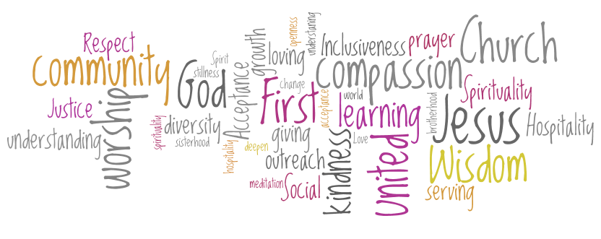

Sunday, April 22, 2018
10:30am

7 Curtis St., St.Thomas, ON N5P 1H3 Phone: (519) 631-7570
e-mail: firstunited@bellnet.ca
web: www.firstunitedchurch.weebly.com
MINISTERS: ALL THE PEOPLE OF GOD
Pastoral Minister: Rev. Emmanuel K. Ofori
Music Minister: Jody McDonald-Groulx
Secretary/Treasurer: Lori Hoffman
Custodian: Dave Luftenegger

