First United Church
Seeking to be a welcoming community of Christian faith, proclaiming and celebrating the love of God in Jesus Christ through the Inspiration of the Holy Spirit

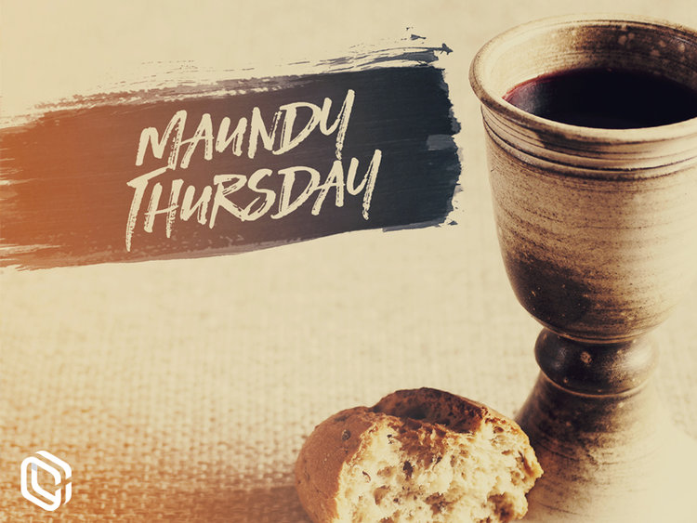

Thursday, April 18, 2019
7pm

7 Curtis St., St.Thomas, ON N5P 1H3 Phone: (519) 631-7570
e-mail: office@1stunitedchurch.ca
web: www.1stunitedchurch.ca
MINISTERS: ALL THE PEOPLE OF GOD
Pastoral Minister: Rev. Emmanuel K. Ofori
Music Minister: Jody McDonald-Groulx
Secretary/Treasurer: Lori Hoffman
Custodian: Dave Luftenegger

Maundy Thursday Worship
WELCOME AND INVITATION
Welcome to this Holy Thursday Worship Service. The alternative title for this day is MAUNDY THURSDAY which recalls the new commandment Jesus gave His disciples at the Last Supper in John 13:34. Maundy is derived from the Latin word Mandatum which means “Commandment”.

CALL TO WORSHIP
One: In remembrance, we gather:
All: to be with the One who teaches us
the meaning of faithfulness.
One: In remembrance, we worship:
All: lifting our voices to the One
who calls us to love one another.
One: In remembrance, we feast:
All: breaking the Bread which makes us whole, drinking the Cup which fills us with grace.

HYMN: VU#595 “The Servant Song”

PRAYER OF THANKSGIVING
ALL: Almighty God, ruler of the universe, we thank you for your mighty acts of deliverance. You enable us to cross over from despair to hope, from brokenness to wholeness, from death to life. We thank you for the deep love of Jesus, which moved him to give himself for the redemption of all creation. We thank you for the grace we experience in receiving these symbols of the life Christ gave for others, and for us. Amen.

PRAYER OF CONFESSION
One: Sisters and brothers, Christ shows us His love by becoming a humble servant. Let us draw near to God and confess our sin in the truth of God’s Spirit. Merciful God, we confess that so often our discipleship has been weak ... when we have failed to serve as Jesus served;
All: forgive us.
One: When we have failed to love one another as Jesus loves us;
All: forgive us.

One: When we have been happy to proclaim our devotion to Jesus with our lips and then denied him by our actions;
All: forgive us.
One: Merciful God, empower us by your Spirit to be steady and true to you in every time of trial; through Jesus Christ our Lord.
All: Amen
INDIVIDUAL PRAYERS OF CONFESSION

ASSURANCE OF FORGIVENESS
One: Jesus said: "I came not to judge the world, but to save the world "(John 12:47b) and "having loved his own who were in the world, he loved them to the end" (John 13: 1b) The good news therefore is this: In Jesus Christ, we are loved and we are forgiven.
All: Thanks be to God! Amen

HYMN: VU #367 “Come Down, O Love Divine"

SCRIPTURE READING: John 13:34-35; 1 Cor. 11:23-26

REFLECTION

ANTHEM: The Senior Choir

SHALOM (Peace Greeting or Kiss of Peace)

COMMUNION

Words of Institution
L: On the night of his arrest Jesus took bread …

Prayer of Consecration
ALL: Creator God, we thank you for the nourishment you give us --for bread, and fruit of the vine. God of freedom, we thank you that you do not leave us in bondage, but act in power to liberate us from all oppression.

We thank you that Christ, acting in courage and faith, has won for us the victory over sin and death.

May the bread and wine be signs of your renewed covenant with us, and may we be ever faithful, until the coming of your final Shalom, when Christ shall come to usher in your eternal reign. In His holy name we pray. Amen.

Sharing of Elements

PRAYER
Leader: Let us join Christ in the garden of prayer.
People: Let us join Christ in passion and victory. Amen.

HYMN: VU#958 “Halle Halle Halle”

BENEDICTION
Go into the world in peace, knowing that God has made the ultimate sacrifice through Jesus, who is the Christ.
Love one another, as Christ loves you, now and forever. Amen.

