Third Sunday of Easter

PREACHER: Rev. Emmanuel K. Ofori
* You are invited to stand if comfortable doing so

VU = Voices United MV = More Voices

We Gather Together
Choral Prelude
- MV#51 Yahweh Be Praised
Yahweh be praised in the heavens. Yahweh be praised in the streets. Yahweh be praised with our singing when in worship we meet. Yahweh be praised. Yahweh be praised. Yahweh be praised. Yahweh be praised. Yahweh be praised. Yahweh be praised. Yahweh be praised. Yahweh be praised. (2x)

- Awesome God
Our God is an awesome God, and reigns from heaven above with wisdom, pow’r and love, Our God is in awesome God. (2x)

Opening Prayer
*Hymn: VU #273 “The King of Love My Shepherd Is”
Lighting of the Christ Candle
Passing of the Peace (VU 958 “Halle, Halle, Halle”)
Welcome
Life and Work of the Church (see insert)

We Draw Near to Worship
Call to Worship
One: The Lord harkens to our call, listening to our pleas and hearing our prayers!
All: We will praise God who gives rest to our souls!

One: In the courts of the house of the LORD, in the presence of all God’s people, we acknowledge our faith.
All: We will call on the Lord as long as we live!

One: We are your servant, O God; you have loosed our bonds!
All: We will offer sacrifices of praise and thanksgiving!

One: How shall we repay the Lord for all we have been given?
All: We will lift up the cup of salvation and call on the name of the Lord!

Silence
Prayers of the Faithful
Intercessory Prayer
We have prayed all these through Christ Jesus our Lord; He is the One who taught us to pray saying … “Our Father …”
The Lord’s Prayer
Circle Time (with the Children)
* Children’s Hymn of Praise: VU#365 “Jesus Loves Me”
Senior Choir Anthem

We Listen for God’s Word
Scripture Readings
New Testament: Acts 2:42-47
Reader: This is the Work of God
All: Thanks be to God.

* Hymn of Preparation: VU #331 “The Church’s One Foundation”

The Message: “Called to be Healthy a Church”

We Respond in Love
Offering
Doxology
God of love, hear our prayer, bless this offering we bring you.
May our lives do your will, guide and guard us forever.
Give us courage to stand for truth, help us give to others.
God of love, hear our prayer, bless this offering we bring you.
Offertory Prayer
We Go Out to Serve
*Closing Hymn: MV#154 “Deep In Our Hearts”
* Benediction
* Triple Amen
* Commissioning Hymn: MV#209 “Go Make A Difference”
* Musical Postlude
TODAY’S MESSAGE
All living things grow if they’re healthy. You don’t have to make them grow – it’s just natural for living organisms.

The same principle is true for the church. As a living organism, when the Body of Christ becomes unbalanced, disease occurs. Since the church is a living organism, it’s natural for it to grow if it’s healthy.

In Acts 2:42-47, the early church models for us the vital signs of a healthy church. Theirs was a …
- Worshipping Community (Acts 2:42, 47)

W –

- Evangelistic Community (Acts 2:27)

E –

- Loving Community (Acts 2:46-37)

L –

- Learning Community (Acts 2:42)

L –

- Serving Community (Acts 2:45)

S –

Think about this:
“As each part does its own special work, it helps the other parts grow, so that the whole body (the church) is healthy and growing. …”
(Ephesians 4:16b, NLT)

First United Church
Seeking to be a welcoming community of Christian faith, proclaiming and celebrating the love of God in Jesus Christ through the Inspiration of the Holy Spirit

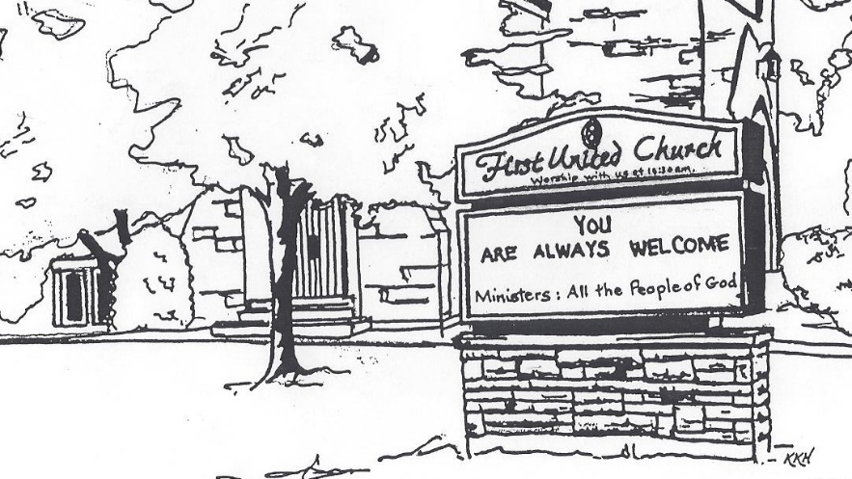

Sunday, April 15, 2018
10:30am

7 Curtis St., St.Thomas, ON N5P 1H3 Phone: (519) 631-7570
e-mail: firstunited@bellnet.ca
web: www.firstunitedchurch.weebly.com
MINISTERS: ALL THE PEOPLE OF GOD
Pastoral Minister: Rev. Emmanuel K. Ofori
Music Minister: Jody McDonald-Groulx
Secretary/Treasurer: Lori Hoffman
Custodian: Dave Luftenegger

