2nd Sunday of Easter

PREACHER: Rev. Emmanuel K. Ofori
* You are invited to stand if comfortable doing so

VU = Voices United MV = More Voices

We Gather Together
Choral Prelude
Opening Prayer
*Hymn: VU #179 “Hallelujah, Hallelujah, Give Thanks”
Lighting of the Christ Candle
Passing of the Peace
Gathering Hymn: VU #958 “Halle, Halle, Halle”
Welcome
Life and Work of the Church (see insert)

We Draw Near to Worship
Call to Worship
One: The Lord is risen!
All: He is risen indeed!
One: You came from heaven to earth
All: to show the way,
One: from the earth to the cross
All: my debt to pay
One: from the cross to the grave
from the grave to the sky
All: Lord I lift your name on high.
One: Christ is risen! Hallelujah!
All: He is risen indeed!

Silence
Prayers of the Faithful
Intercessory Prayer
We have prayed all these through Christ Jesus our Lord; He is the One who taught us to pray saying … “Our Father …”
The Lord’s Prayer (Sung) (VU#560)
Children’s Time “Stop; and Let Me Tell You”
Stop; and let me tell you  What the Lord has done for me.  Stop; and let me tell you  What the Lord has done for me.  He forgave my sin  And He saved my soul,  He cleansed my heart  And He made me whole.  Stop; and let me tell you  What the Lord has done for me. | Go and tell the story  Of the Christ of Calvary,  Go and tell the story  Of the Christ of Calvary:  He'll forgive their sins,  He will save their souls,  He'll cleanse their hearts,  He will make them whole.  Go and tell the story  Of the Christ of Calvary.
Church Choir

We Listen for God’s Word
Scripture Readings
Old Testament: 2 Kings 7:1-9
Reader: This is the Word of God.
All: Thanks be to God.

Gospel Reading: Mark 16:9-20
Reader: This is the Gospel of Christ.
All: We praise You, O Christ.

* Hymn of Preparation: VU #343 “I Love to Tell the Story”
The Message: “Go and Tell the Story”

We Respond in Love
Offering
Offertory Dedication Hymn
God of love, hear our prayer, bless this offering we bring you.
May our lives do your will, guide and guard us forever.
Give us courage to stand for truth, help us give to others.
God of love, hear our prayer, bless this offering we bring you.
Offertory Prayer
We Go Out to Serve
*Closing Hymn: VU# 509 “I, the Lord of Sea and Sky”
* Benediction
* Triple Amen
* Commissioning Hymn: MV#209 “Go make a difference”
* Musical Postlude
TODAY’S MESSAGE

Last week was Easter Sunday as we celebrated the resurrection of our Lord Jesus Christ. We are still in the Easter mood. We know that the gospel of our Lord Jesus Christ does not end with Christ’s dying, or even His rising from death, but continues with His living again in us by the power of the Holy Spirit. This fact so transforms our relationship and responsibility to Him that we become the heralds of life, hope, and joy in a world that is lifeless, hopeless, and cheerless.

- Before seeing the risen Christ
We, like Mary, have ….
- Blurred Vision in our perception

- Bad Judgment in terms of our perspective

- Blocked Purpose in Life.

- After seeing the risen Christ
We, like Mary, experience a …
- Change of Relationship to Christ

- Change of Responsibility to Christ

Think about This!
Jesus is still revealing Himself to men and women, and giving them new responsibilities or commissioning them to be witnesses for Him to others.

- Mary “went out and told …” (Mark 16:10)

- The two disciples on the road to Emmaus “returned and reported ….” (Luke 24:33-35)

- After Jesus’ ascension, the disciples “went out and preached …” (Mark 16:20)

- The lepers said to one another “… let us go and tell …” (2 Kings 7:9)

First United Church
Seeking to be a welcoming community of Christian faith, proclaiming and celebrating the love of God in Jesus Christ through the Inspiration of the Holy Spirit
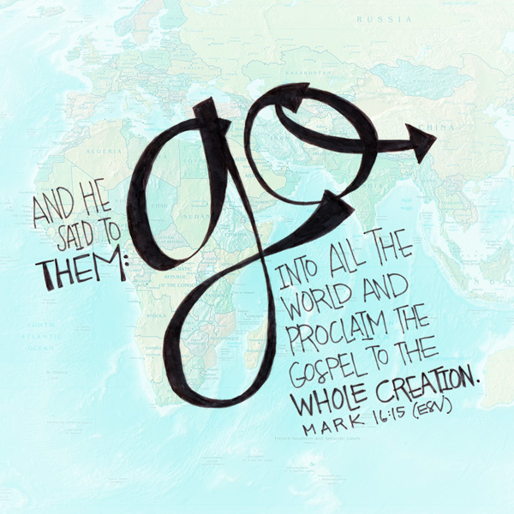

Sunday, April 8, 2018
10:30am

7 Curtis St., St.Thomas, ON N5P 1H3 Phone: (519) 631-7570
e-mail: firstunited@bellnet.ca
web: www.firstunitedchurch.weebly.com
MINISTERS: ALL THE PEOPLE OF GOD
Pastoral Minister: Rev. Emmanuel K. Ofori
Music Minister: Jody McDonald-Groulx
Secretary/Treasurer: Lori Hoffman
Custodian: Dave Luftenegger

