First United Church
Seeking to be a welcoming community of Christian faith, proclaiming and celebrating the love of God in Jesus Christ through the Inspiration of the Holy Spirit

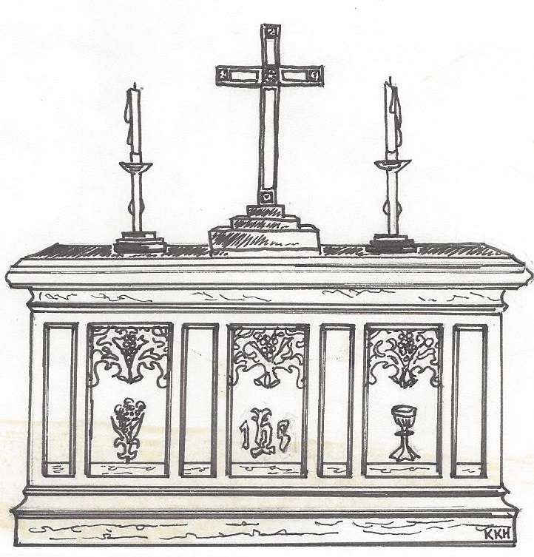

Announcements
April 07, 2019 @ 10:30am

7 Curtis St., St.Thomas, ON N5P 1H3 Phone: (519) 631-7570
e-mail: office@1stunitedchurch.ca
web: www.1stunitedchurch.ca
MINISTERS: ALL THE PEOPLE OF GOD
Pastoral Minister: Rev. Emmanuel K. Ofori
Music Minister: Jody McDonald-Groulx
Secretary/Treasurer: Lori Hoffman
Custodian: Dave Luftenegger

The Life & Work of the Church
for April 7, 2019

*TODAY –Everyone is invited to gather in the Fellowship Room for refreshments and a time of fellowship Room following worship.

This week:
Tuesday: *EarlyON Playgroup in the gym - 9:30 – 11:30am

Thursday – *Youth Group with Chris Ross (grades 8-12 every week) & Justin Chute (grades 5-7 every other week) in the Gym from 7-8:15pm.
*Sr. Choir @ 7:30pm in the Music Room- come and give it a try!

Saturday: - *First Church & Friends Artisan & Vendor Market – Saturday, April 13th from 10am to 2pm. We hope to have as many Artisans & Vendors as possible so we can have a SUPER SUCCESSFUL event and raise some money for the General Fund!! We have a few spaces left!! So if you are an Artisan/Crafter/Baker, etc. or if you are involved in direct sales – WE’D LOVE TO HAVE YOU PARTICIPATE! {We will only be accepting ONE direct sales Vendor per company (ex. 1 Scentsy, 1 Tupperware, 1 Epicure, etc., as we want everyone to have a profitable day! So make sure you contact Lori in the office (office@1stunitedchurch.ca) ASAP to reserve your space! Don’t be disappointed!} Applications can be found on our website!

Future Dates / Events
Lent & Easter at First
Sunday, April 14 – Palm Sunday
Thursday, April 18 – Maundy Thursday – Worship @ 7pm
Friday, April 19 – Good Friday – Worship @ 10:30am
Sunday, April 21 – Easter Sunday – Worship at 10:30am

*Bean Blast in support of the Community Dinners at Trinity is being held on Thursday, April 18 from 11:30am to 1pm at St. Anne’s Centre. - There will be Door Prizes & Entertainment. Tickets are $5 in advance of $6 at the door. For more info or to get tickets call Jean Johnson @ 519-631-8877.

*The Youth Group will be attending “The Swell” at Wesley Knox United Church in London on Friday, April 19 @ 7pm.

*The Youth Groups will be participating in an Earth Day Cleanup on Monday, April 22 (time TBA) If you’d like to join them let Chris or Justin know

*Spring Rummage Sale – Saturday, April 27 from 8:30-11:30am
Looking for donations of good gently used spring and summer clothing for all ages, shoes, purses and jewellery. We are looking for all types of home decor, pictures, knic knacs, antiques, bedding, towels, tableware as well as toys, books and games. Please no TVs, computers or microwaves. Drop off donations inside west accessibility door Mon to Thurs from 9am-2pm. Call Lois W. 519-631-3337 if you are able to help sort, price or work on sale day. Thankyou!

*El Sistema Concert at First! Sunday, April 28 at 2:30pm. Tickets are $10 and are available in the Church office!

*Mom to Mom Sale – Saturday, May 25 from 9am to 1pm. We are renting out spaces for those who have an overabundance of children’s clothes/supplies so they can come and sell some of it
– and probably buy some more from other parents who are here!
If you’d like a space call or email Lori in the Church office! (office@1stunitedchurch.ca)
*First United is hiring a Family & Youth Ministry Co-ordinator! For more information or to see the job description please visit our website: www.1stunitedchurch.ca/family--youth-ministry-co-ordinator-position.html. All cover letters and applications can be sent to the attention of the Ministry & Personnel Committee at personnel@1stunitedchurch.ca
.
Minister’s Drop-In Office Hours
Tuesday, Wednesday & Thursday 10am to 12 Noon
*Other times available by appointment, call 519-631-7570 ext. 22
From the Finance Committee
The Finance Committee is continuing to ask for your support via online donations through PAR/Paypal. Once set up, these donating vehicles provide very efficient, user friendly and cost-saving methods of supporting our church. You will find new laminated cards in the pews for use by those families donating via PAR or PayPal. We encourage those of you who have embraced online donations to put these cards on the offering plate during the Offertory to promote this initiative. Should you need any help in adopting either of these two methods, please contact Lori in the church office and she or another member of the Finance Committee will assist you. Thank you!

TODAY’S MESSAGE
The Christian life is essentially a relationship with a Person. God longs to have relationship with us. We cannot enter such a relationship with God, but “we are made right with God by placing our faith in Jesus Christ. And this is true for everyone who believes, no matter who we are”
(Romans 3:22).
When we place our faith in Jesus and Him, we are inspired us to love Him, share His truth, and continue following Him.

- What happens when you are made right with God?
Through God’s grace, unmerited favour …
- You are a child of God
- The Holy Spirit comes to dwell inside you
- You become a new creation in Christ or born again
- Your sins are forgiven and forgotten
- You have Eternal Life and your salvation is secure in Christ
- You are made part of the Body of Christ

- This is good news which must be shared
Nathanael said to him, “Can anything good come out of Nazareth?” Philip said to him, “Come and see” (John 1:46)

You may feel like you aren’t qualified to share the love of God in Christ. Wait! You are not alone.

Simply tell your own story of conversion, healing, and the hope Jesus brought to your life that changed everything forever. All it takes is to invite another person to “come and see”.

Think about this
There is always room for one more.
You can pray for one person, share the love of God with the one and invite the one to church.

