First United Church
Seeking to be a welcoming community of Christian faith, proclaiming and celebrating the love of God in Jesus Christ through the Inspiration of the Holy Spirit

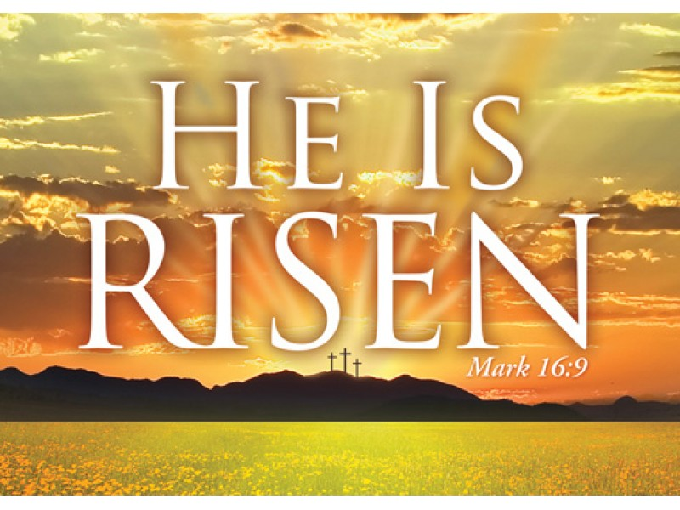

Easter Sunday
April 1, 2018 @ 10:30am

7 Curtis St., St.Thomas, ON N5P 1H3 Phone: (519) 631-7570
e-mail: firstunited@bellnet.ca
web: www.firstunitedchurch.weebly.com
MINISTERS: ALL THE PEOPLE OF GOD
Pastoral Minister: Rev. Emmanuel K. Ofori
Music Minister: Jody McDonald-Groulx
Secretary/Treasurer: Lori Hoffman
Custodian: Dave Luftenegger

First United Church, St. Thomas
EASTER WORSHIP SERVICE
CELEBRATION OF CHRIST’S RESURRECTION
April 01, 2018 - 10:30 a.m. Worship
Preacher: Rev. Emmanuel K. Ofori

Notes: Asterisk (*) – You may stand if able

God Gathers Us Together

Musical/Choral Prelude: “Oh Happy Day”

* Procession Hymn: VU#157 “Christ the Lord is Risen Today”

Life and Work of the Church [see insert]

Welcoming of Visitors

God Draws Us Near To Worship

Call to Worship

One: The Lord is risen!
All. He is risen indeed!
One: The stone which the builders rejected has become the head of the corner.
All: This is the Lord’s doing and it is marvelous in our eyes.
One: Death could not hold Him captive, Hallelujah!
All: Even in the grave He is Lord!
One: Christ is risen!
All: He is risen indeed, Amen

Page 1

Hymn of Praise: VU#173 “Thine Is the Glory”

Prayer of Praise and Adoration
One: Yours is the glory, O God, for raising Jesus from the darkness of death.
All: Yours is the glory, O Christ, for being prepared, through your love and your sacrifice, to conquer death and give us the gift of eternal life.
One: And, as if that were not enough, you greet us by name, as you greeted Mary in the garden, and transform our lives forever with your Easter life.
All: Risen Lord, we worship and adore you;
One: and we pray that the Holy Spirit, Your life in us, will so conform us to your image, that we radiate Your glory here, through our rejoicing and praise, and in all the places where people's lives are still affected by the powers of death and sin.
All: Yours is the glory, O God, for showing us the human face of Your love in Jesus, Your Son, our risen Lord.
One: Yours is the glory, risen Lord Jesus, and we rejoice that 'endless is the victory that you over death have won'. Alleluia! Christ is risen!
All: Christ is risen indeed! Amen

Prayer of Confession
One: God who weaves extraordinary patterns into our ordinary lives;
All: Forgive us for complacency.
Forgive us for taking you and yours for granted.
Forgive us for failing to accept either the cost or the joy of discipleship.
God of the empty tomb, we come to this joyful Easterfest
with eyes focused on the lilies;
guide our timid eyes to the cross.
Remind us again of the tomb; filled and now empty.
Remind us again of Mary's tears; of sorrow and now joy.
Remind us again of Peter's words; denial and now telling.
God of the empty tomb,
grant us the grace to accept both the cost
and the joy of following you.
Page 2
Intercessory Prayer / The Lord’s Prayer (VU #960)

Choir: “He Is Risen”

God Invites Us To Listen For His Word

Old Testament Reading: 1 Corinthians 15:1-11
Reader: This is the Word of God
All: Thanks be to God

Gospel Reading: John 20:1-18
Reader: This is the Gospel Message
All: We Praise You O Christ

*Sermon Hymn: “Because He Lives”
God sent His Son, they called Him, Jesus;
He came to love, heal and forgive;
He lived and died to buy my pardon,
An empty grave is there to prove my Savior lives!

Refrain
Because He lives, I can face tomorrow,
Because He lives, all fear is gone;
Because I know He holds the future,
And life is worth the living,
Just because He lives!

How sweet to hold a newborn baby,
And feel the pride and joy He gives;
But greater still the calm assurance:
This child can face uncertain days because He Lives! R

And then one day, I'll cross the river,
I'll fight life's final war with pain;
And then, as death gives way to victory,
I'll see the lights of glory and I'll know He reigns! R

Message: “Because He Lives”

Page 3

God Invites Us To Respond To His Love
Easter Offertory: Leslie Andrew
Offertory Dedication Hymn
God of love, hear our prayer, bless this offering we bring you.
May our lives do your will, guide and guard us forever.
Give us courage to stand for truth, help us give to others.
God of love, hear our prayer, bless this offering we bring you.

Offertory Prayer

God Invites Us To Break Bread Together

Communion Hymn: VU#480 “Let Us Break Together”

The Lord be with you.

And also with you

Lift up your hearts

We lift up our hearts unto the Lord

Let us give thanks to God

It is good and pleasant to give God thanks and praise

It is a good and pleasant thing, our joy and our moral duty, always and everywhere to give you thanks and praise, O Lord, God, ever-loving and ever-blessed, Almighty and all-loving.

Therefore, with angels and archangels, and with all the heavenly host, we join in the blessed hymn of everlasting praise saying …

Holy, holy, holy,
LORD God of hosts,
heaven and earth are full of your glory.
Hosanna in the highest.
Blessed is the One who comes
In the name of the Lord
Hosanna in the highest
Hossana in the highest
Glory be to you, O Lord, most high.
Amen.
Page 4

*Affirmation of Faith (1 Cor. 15:1-6; Colossians 1:15-20)

One: This is the good news which we have received, in which we stand, and by which we are saved.

All: Christ died for our sins, was buried, was raised on the third day and appeared first to the women, then to Peter and the twelve, and then to many faithful witnesses.
We believe Jesus is the Christ, the Anointed One of God, the first born of all creation, the first born from the dead, in whom the fullness of God was pleased to dwell, by the power of the Spirit.
Christ is the head of the body, the Church, and by the blood of the cross reconciles all things to God. Amen.

The Institution
Blessed are you, Lord God, King of the universe, and blessed is your Son Jesus Christ our Lord; who on the night He was betrayed and arrested He turned to His disciples and said,

“I give you a new commandment, that you love one another. Just as I have loved you, you also should love one another. By this everyone will know that you are my disciples, if you have love for one another”.

Then Christ took bread and looking up to heaven gave thanks, broke it and gave it to His disciples, saying,

“Take this and eat it. This is my body given for you. Do this in remembrance of me.”

In the same way after Supper He took the cup, gave thanks and gave it to them saying,

“Drink from it, all of you. This is my blood of the new covenant poured out for you and for many for the forgiveness of sins. Do this whenever you drink it in remembrance of me.”

Page 5

Therefore, let us proclaim the mystery of our faith …

All: Jesus Christ has died

Jesus Christ is risen

Jesus Christ will come again

For deep in my heart, I do believe

That Jesus Christ will come again

(Sung to tune: “We Shall Overcome” Traditional – arranged by compilers)

Prayer of Consecration
Invitation & Distribution of Elements
Prayer of Thanksgiving

God Sends Out Into the World to Serve

*Closing Hymn: VU 159 “The Strife Is O’er”
* Benediction
*Sending Forth
Threefold Amen
Commissioning Hymn: MV#121 “Hey Now! Singing Hallelujah!”
(v 1, 3, & 5)
* Musical Postlude

Thank you Lesley Andrew, Wayne Carroll and
Patrick Smithers for sharing your musical gifts.

Page 6
TODAY’S MESSAGE
History has done all it can do to keep Jesus in the “tomb”, but it has always failed. Examples are:
- The Swoon or Resuscitation Theory
- The Hallucination Theory
- The Impersonation Theory
- The Spiritual Resurrection Theory
- The Theft Theory
- The Unknown Tomb Theory

The good news is, the tomb is still empty. All these theories are now dead, and the fact still remains:
Jesus rose victoriously from the grave; He is alive forever more.

The resurrection of Christ is just as real today as it was 2,000 years ago! Jesus is just as real, He is just as alive, He is just as powerful, and He brings just as much meaning to our lives now as He did back then.

Therefore… “Because He Lives” you and I can …
- Look back with Thanksgiving for sins forgiven.
The Risen Christ has broken the power of guilt and sin.

- Face Today with confidence for what is in store for us.

- Face Tomorrow with faith for whatever comes our way.

- Embrace Eternity with peace.

Think about this:
- Jesus is the same yesterday, today and forever (Heb. 13:8)
- The tomb could not hold Jesus captive! And “Because He lives”, you and I do not have to fear today, tomorrow, or eternity!

